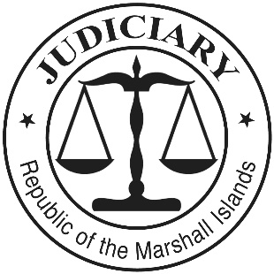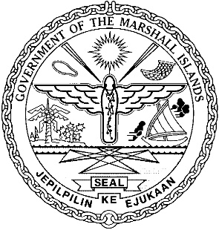

**THE JUDICIARY OF THE**

**REPUBLIC OF THE MARSHALL**

**ISLANDS**

**2017 ANNUAL REPORT**

Table of Contents

Message from the Chief Justice 1

Our Values: 2

Mission Statement: 3

Vision: 3

I. INTRODUCTION 5

II. SIGNIFICANT EVENTS AND ACCOMPLISHMENTS 6

A. Increase in Corporate, Maritime, and Enforcement of Foreign Judgments Cases 6

B. Ebeye Courthouse 7

C. Police Substation for Majuro Courthouse 7

D. Enhanced Training for Lay Judges 7

III. THE COURTS: EFFICIENCY, QUALITY, AND ACCESSIBILITY 9

A. Supreme Court 9

B. High Court 13

1. Civil Cases (other than Probate Cases) 13

2. Probate Cases 20

3. Criminal Cases 23

4. Juvenile Cases 26

5. Caseloads for Judges and Clerks 28

6. Selected Decisions 29

C. Traditional Rights Court 29

D. District Court 31

1. Traffic Cases (Majuro) 31

2. Criminal Cases (Majuro) 35

3. Juvenile Cases (Majuro) 38

4. Small Claims Cases (Majuro) 41

5. Caseload for Judges and Clerks (Majuro) 44

6. Ebeye 44

E. Community Courts 44

F. Travel to the Outer Islands and Ebeye 45

G. Other Services: Births, Deaths, Marriages, Notarizations, etc. 45

1. Majuro. 45

2. Ebeye. 46

H. Court Staff 46

I. Professional Development and Regional Conferences 47

J. Court Rules and Relevant Statutes 53

IV. THE JUDICIAL SERVICE COMMISSION: JUDICIAL APPOINTMENTS 54

V. ACCOUNTABILITY: CODES OF CONDUCT AND COMPLAINTS 54

VI. FACILITIES, TECHNOLOGY, AND LIBRARY 55

A. Facilities 55

B. Technology 56

C. Library 56

VII. ANNUAL BUDGET AND AUDIT REPORT 57

Appendix 1 58

Appendix 2 59

Appendix 3 61

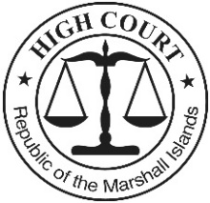

**High Court**

**of the**

**Republic of the Marshall Islands**

Post Office Box B

Majuro, MH 96960

Tele.: 692-625-3201

Email: Marshall.Islands.

Judiciary@gmail.com

# Message from the Chief Justice

Iakwe, I am pleased to present the 2017 Annual Report for the Judiciary of the Republic of the Marshall Islands. As in past years, this report reflects the dedication and hard work of the judges and staff who serve the Judiciary, the Government, and the people of the Marshall Islands. It is my pleasure and a privilege to work with them.

On behalf of the Judiciary, I wish to express our sincere appreciation to the President, the Minister of Justice, and the other members of the Cabinet for their support in 2017. Also, I wish to express our profound thanks to the Nitijela and the House of Iroij for their continuing support of our budgetary and legislative requests. We are committed to working with the Cabinet, the Nitijela, and the House of Iroij in the years to come to maintain a judiciary that is fair and efficient, assuring justice and the rule of law for all. Our shared goals mandate that we work together in a spirit of respect and cooperation.

Submitted with the 2017 Annual Report are our updated Values, Mission Statement, and Vision Statement. For more information about the Judiciary, please contact me or the Chief Clerk of the Courts at the above address.

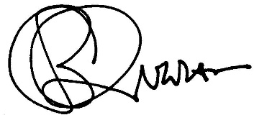 Sincerely yours,

_________________________

Carl B. Ingram

Chief Justice, High Court

Date: June 29, 2018



# Our Values:

***Tomak, Jenok, im Aurok Ko Ad:***

The Marshall Islands Judiciary holds the following values and desires to operate in a manner that is, and will be perceived as:

*Jikin Ekajet ko an Marshall Islands rej debij im jerbal wot iumin tomak, aurok eo,im konan eo non air jerbal ilo wawein ko renaj koman bwe armej ren kalimjeklok ra eo an Jikin Ekajet bwe ej juon eo ej einwot in:*

* accessible
* accountable
* competent
* consistent
* efficient
* fair and impartial
* independent
* respectful and
* service-oriented,
* valuing custom and tradition, as well as innovation.

*ebellok non aoleb armej*

*etiljek, ekkeke, im maron uwak non jerbal ko an*

*ekakemooj im emmon an komane jerbal eo an*

*ej jokkin wot juon an komane jerbal eo an*

*ebolemen im tiljek ilo an kakke aikuij ko*

*ej jerbal jimwe ilo ejelok kalijeklok im jeb*

*ejenolok im jutaklok ian make*

*ewor an kautiej armej im*

*etiljek, jela nae, jela kunaan, im jela karejar iben armej,*

*ej kaurok im kautiej manit im men ko bwinnid im ad jolet*, *ekoba lomnak im wawein jerbal ko rekaal*.

These values form the basis for the Judiciary’s Mission Statement and Vision.

*Tomak im aurok kein rej ejaake bedbed eo non kottobar im ettonak kein ilal.*

# Mission Statement:

***Kottobar Eo*:**

The mission of the courts of the Marshall Islands, the Judiciary, is to fairly, efficiently, andeffectively resolve disputes properly brought before them, discharging their judicial duties and responsibilities in accordance with the Constitution, laws, and customs of this unique island nation, for the benefit of those who use the courts’ services.

*Kottobar eo an Jikin Ekajet ko an Marshall Islands ej non jerbal jimwe ilo ejelok kalijeklok, bolemen im tiljek ilo an kakke aikuij ko ilo aoleb abnono ko rej itok imair, im non komane jerbal in ekajet im edro ko air ekkar non Jemen-Ei eo, kakien ko, im manit ko an ailon kein ad im jej jenolok kaki jen lal ko jet ikijien manit im men ko bwinnid im ad jolet, non emmanlok eo an ro rej bok jiban jen jikin ekajet eo.*

# Vision:

***Ettonak Eo:***

The Marshall Islands Judiciary will be an excellent small-island judiciary, deserving of public trust and confidence.

* The Judiciary will be fair and impartial.
* The Judiciary will treat court users and colleagues with dignity, courtesy, and respect, and will require the same in return.
* The Judiciary will provide affordable and accessible services to court users.
* The Judiciary will seek to resolve matters efficiently, while maintaining quality, consistency, and certainty.
* The Judiciary will be independent yet accountable, deciding matters based upon the facts before the courts and a conscientious understanding of the law and custom.
* The Judiciary will administer the courts in accordance with internationally recognized standards for leadership, management, and accountability.
* The Judiciary will seek and employ innovative practices and procedures to better serve court users, to identify users’ needs, and to develop court personnel.
* The Judiciary will maintain adequate and safe courthouses and a supportive work environment.

*Ra eo an jikin ekajet eo an Marshall Islands enaj juon eo ebolemen, im ebed liki im kojatdrikdrik an armij ro ie.*

* *Ra eo an jikin ekajet eo enaj jerbal jimwe ilo ejelok am kalijeklok.*
* *Ra eo an jikin ekajet eo enaj kile, kautej, im karejar ippen ro rej kojerbal im bukot jiban jen jikin ekajet eo, ekoba dri-jerbal ro mottam, im enaj kotmene bwe armij naj ukot tok ilo ejja wawein kein wot.*
* *Ra eo an jikin ekajet eo enaj komman bwe en drik wonen, bidodo, im ejelok aban non ro rej kojerbal im bok jiban jen jikin ekajet eo.*
* *Ra eo an jikin ekajet eo enaj bukot kojkan bwe en mokaj, emman, im jejjet wawein am bukot mejlan ailwaro im aikuj ko.*
* *Ra eo an jikin ekajet eo enaj komman jemlok non abnono ko, ilo an ejelok kibel jen ijoko jabrewot, bedbed wot ion menin kamol ko rej walok, im jen am melele kin kien im manit.*
* *Ra eo an jikin ekajet eo enaj kommani jerbal im eddro ko an court ekkar non jonak im wawein ko lal in ej kili im lori ikijen jerbal in tel, lolorjake, im bok eddro.*
* *Ra eo an jikin ekajet eo enaj bukot im kojerbal wawein im rebeltan jerbal ko rekaal bwe en emman lok am kake aikuj ko an ro rej kojerbal jikin ekajet eo, im bareinwot non am kolablok kabeel ibben dri-jerbal ro ilo jikin ekajet eo.*
* *Ra eo an jikin ekajet eo enaj lolorjake bwe jikin ekajet ko ren ainemmon im bolemeir, im bwe jitbon jerbal in ippen dron eo en wonmanlok wot.*

**2017 REPORT**

**OF THE JUDICIARY OF THE**

**REPUBLIC OF THE MARSHALL ISLANDS**

# I. INTRODUCTION

The Republic of the Marshall Islands consists of two nearly parallel island chains of 29 atolls and five separate islands—1,225 islands in all—located about half way between Hawaii and Australia. The Republic’s land mass totals 70 square miles scattered over 750,000 square miles of the Pacific Ocean. As of January 1, 2017, the estimated population of the Marshall Islands was approximately 55,036. However, estimates vary greatly.

The Republic of the Marshall Islands is a young nation. After more than three decades of United States administration under the United Nations Trust Territory of the Pacific Islands (TTPI), the Marshall Islands commenced constitutional government on May 1, 1979, as part of a process toward self-government. Seven and half years later, on October 21, 1986, the Marshall Islands formally regained independence through an agreement with the United States, the Compact of Free Association. The Republic is now self-governing under its own constitution.

Under the Constitution, the Marshall Islands has a Westminster-style government with a 33-member parliament called the Nitijela. At least every four years, after national elections, the Nitijela elects from its members a president, who in turn selects eight to ten other Nitijela members for his or her cabinet. The Constitution vests legislative authority in the Nitijela (the parliament) and the Imon Iroij (House of Chiefs), executive authority in the Cabinet, and judicial authority in the judiciary (“RMI Judiciary”).

Article VI of the Constitution provides for a judiciary “independent of the legislative and executive powers.” The RMI Judiciary comprises five levels of courts, as well as a Judicial Service Commission and court staff. The courts include the Supreme Court, the High Court, the Traditional Rights Court, the District Court, and the Community Courts. The RMI Judiciary officially commenced operation on March 3, 1982, assuming judicial functions in the Marshall Islands, which had been discharged by the High Court of the TTPI. An organizational chart of the RMI Judiciary is attached as Appendix 1, and a listing of RMI Judiciary personnel at the end of calendar year 2017 is attached as Appendix 2.

In the sections that follow, this report summarizes the RMI Judiciary’s operations and accomplishments in calendar year 2017, as well as its challenges, including the need for financial support. These sections include the following:

* Significant Events and Accomplishments;
* The Courts: Efficiency, Quality, and Accessibility;
* The Judicial Service Commission: Judicial Appointments;
* Accountability: Codes of Conduct and Complaints;
* Facilities, Technology, and Library; and
* Annual Budget and Audit Report.

# II. SIGNIFICANT EVENTS AND ACCOMPLISHMENTS

The dedication and hard work of the judges and staff that serve the RMI Judiciary made 2017 a successful year. The most significant events and accomplishments include the following:

* Significant rise in the number of cases involving corporations, maritime, and enforcement of foreign judgments;
* Completed initial plans and drawings for a new courthouse on Ebeye;

* Built a police substation next to the Majuro Courthouse; and
* Provided enhanced training for lay judges.

## Increase in Corporate, Maritime, and Enforcement of Foreign Judgments Cases

In 2017, the RMI Judiciary experienced a significant increase in the number of cases involving corporations, maritime, and enforcement of foreign judgments. The number of such cases has gone from four in 2015, to 10 in 2016, to 20 in 2017. Of the 40 cases, 14 remain pending. These cases tend to be very complex and require hundreds of hours of High Court judge time. Also, in June 2018, the only cases heard on appeal by the Supreme Court were four non-resident corporate, enforcement of judgments, and maritime cases.

As the Marshall Islands Ship Registry and the Marshall Islands Trust Company grow, more non-resident disputes are being heard by the High Court and the Supreme Court. This is particularly true when there is a down turn in the global economy. Because is this increased workload, the RMI Judiciary requests funding for a third High Court justice. The third justice also is needed to ensure that the needs of the people of the Marshall Islands are met, particularly those on Kwajalein and the outer islands. The additional personnel cost for a third High Court judge would be about $120,000. The RMI Judiciary seeks a budget increase to cover this cost and related expenses.

## Ebeye Courthouse

In 2017, the RMI Judiciary completed detailed plans and drawings for a new courthouse on Ebeye. The new courthouse would include office space for a prosecutor and defense counsel, as well as a ground floor court room, judges’ chambers, and clerk’s office. The cost to construct and furnish the new courthouse would be approximately $800,000. The RMI Judiciary was not able to obtain funding for the project in the FY 2018 budget but will continue to seek funding for this vital project.

## C. Police Substation for Majuro Courthouse

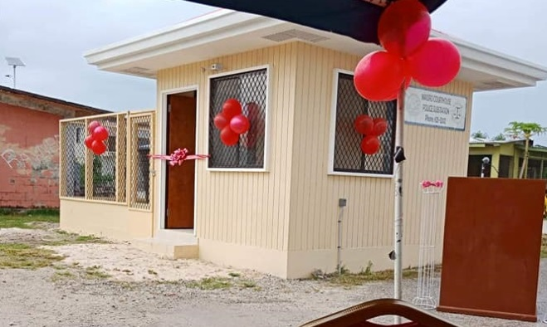

In late 2017 the RMI Judiciary commenced construction of a National Police Substation next to the Majuro Courthouse. The project was completed in early 2018. The station is manned by officers from the National Police Department. The aim of the new police substation is to address nighttime vandalism and assaults in the area.

## D. Enhanced Training for Lay Judges

The RMI Judiciary with support from the Pacific Judicial Strengthening Initiative (PJSI), funded by the Government of New Zealand and administered by the Federal Court of Australia, conducted in Majuro from August, 10-18, 2017 two activities: (i) a Local Train-the-Trainer (TOT) Workshop and (ii) a Lay Judicial Orientation Workshop for the RMI Community Court Judges. The aims of these workshops were two-fold: first to build the competence and confidence of RMI’s faculty of judicial trainers to plan, deliver and manage judicial training on an ongoing local basis, (including facilitating the Lay Judicial Orientation Workshop for Community Court Judges) and second to induct lay judges of RMI’s Community Courts in the fundamentals of judicial knowledge skills and attitudes in order to perform their roles more competently.

Train-the-Trainer (TOT) Workshop (August 10-11, 2017): The intensive two-day TOT provided the orientation faculty with a ‘refresher’ of PJSI’s *Judges’ Orientation* and *Trainers’ Toolkits*. The faculty included members of the RMI Judiciary’s training team, most of whom are accredited trainers, and Judge Jane Patrick from the County Court of Victoria. The faculty greatly benefited from the participation of Judge Patrick, who shared her vast experience and insight across the spectrum of judicial practice. There was a total of nine TOT participants, five of whom (55%) were female. Day 1 focused on the theory of adult learning. Day 2 focused on preparing and the delivery of presentations, with peer-based feedback. The TOT was facilitated by PJSI’s Director, Dr. Livingston Armytage. At the conclusion of the TOT, all trainers had developed and refreshed their presentation skills.

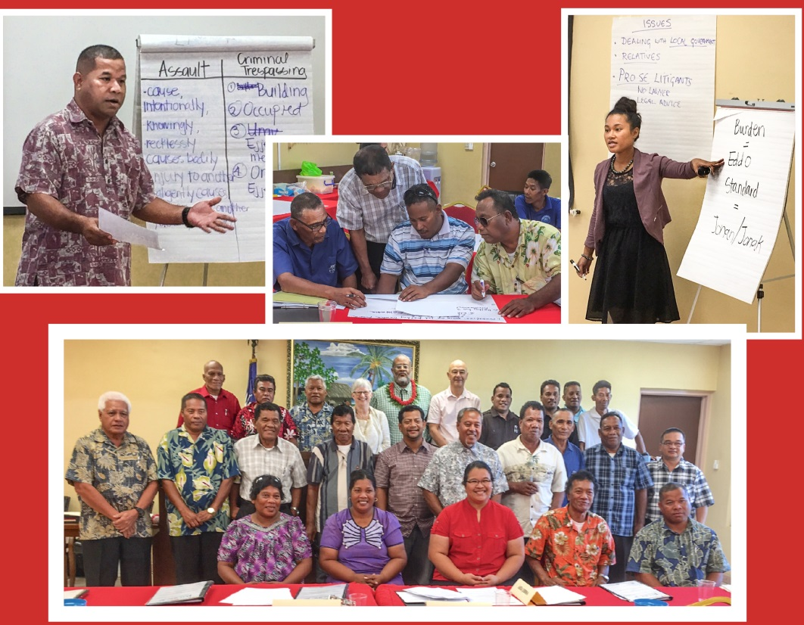Lay Judicial Orientation Workshop (August 14-18, 2017): This five-day orientation workshop provided lay judges of the Community Courts from across the Republic. For the judges, this was their first structured induction on the basic principles and practices of the judicial role. The orientation was presented by a faculty of nine judicial and clerical officers from the Republic’s courts, together with Judge Jane Patrick from the County Court of Victoria and PJSI’s Dr. Armytage. The faculty successfully applied a range of presentation skills developed and refreshed in the preceding TOT. There was a total of 17 Orientation participants, two of whom were female (12%), together with the faculty members who also sat in this course, in all a total of 26 participants, of whom in total seven were female (27%). At the conclusion of the orientation, participants assessed their satisfaction with the training very at 94.4% and the usefulness of the information supplied at 98.25%. These scores highlight the participants’ active participation in the orientation training.

These activities build on PJSI’s accumulating experience supporting the delivery of judicial training to lay judges across the region. Also, these activities evidence progress both (i) in elevating the threshold of basic knowledge of Community Court judges across the Republic and (ii) in building the capacity and confidence of the Republic’s courts to delivery their own judicial training on an ongoing basis.

# III. THE COURTS: EFFICIENCY, QUALITY, AND ACCESSIBILITY

The goals of the RMI Judiciary include to be efficient, to produce quality decisions, and to be accessible.

* The RMI Judiciary’s **efficiency** can be measured by annual clearance rates, time standards, the age of cleared cases, and the age of pending cases.
* The **quality** of decisions can be measured by appeals and cases overturned on appeal.
* **Accessibility** can be measured by fee waivers, lower fees for vulnerable litigants, cases heard on circuit, free legal counsel, the availability of forms, and the accessibility of courthouses.

To these ends, the 2017 Annual Report reviews all five levels of the RMI Judiciary—the Supreme Court, the High Court, the Traditional Rights Court, the District Court, and the Community Courts. The review includes the courts’ jurisdictions, staffing, and case statistics, as well as continuing professional development for judges and staff.

## A. Supreme Court

The Supreme Court, the court of last resort, is a superior court of record having appellate jurisdiction with final authority to adjudicate all cases and controversies properly brought before it. An appeal lies to the Supreme Court:

(i) as of right from a final decision of the High Court in the exercise of its original jurisdiction;

(ii) as of right from a final decision of the High Court in the exercise of its appellate jurisdiction, but only if the case involves a substantial question of law as to the interpretation or effect of the Constitution; and

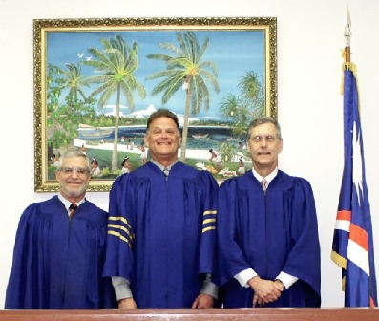(iii) at the discretion of the Supreme Court from any final decision of any court.

Also, the High Court may remove to the Supreme Court questions arising as to the interpretation or effect of the Constitution.

The Supreme Court consists of three justices: a chief justice and two associate justices. To date, all Supreme Court judges have been law-trained attorneys and most have been experienced judges. The current chief justice, Daniel N. Cadra, is a United States citizen appointed to a second 10-year term effective September 2013. Generally, associate justices have been acting judges from other jurisdictions — the United States Ninth Circuit Court of Appeals, the United States Federal District Court in Hawaii, the Republic of Palau, the Commonwealth of the Northern Mariana Islands, and Canada. In 2017, the acting associate justices were two United States Federal Court judges from the Federal District Court in Hawaii: District Court Judge Michael Seabright and Magistrate Judge Barry Kurren. The Chief Clerk of the Courts, Ingrid K. Kabua, serves as the clerk of the Supreme Court.

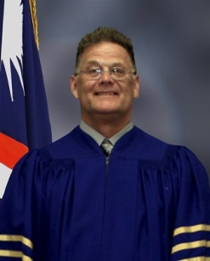The Supreme Court’s 2017 case and workload are summarized below, including annual clearance rates, annual average age of cleared cases, and annual average age of pending cases.

At the beginning of 2017, there were five matters pending before the Supreme Court, and in 2017, another six matters were filed. In 2017, five cases were decided: High Court decisions in two land cases were affirmed; an opinion was issued confirming the need for an act of the Nitijela to make the provision of a treaty domestic law; and two writs directed against High Court justices were denied. By the end of 2017, six cases remained.

The Supreme Court’s goal is to maintain over time an annual clearance rateof 100%. As the table below shows, the Supreme Court has done this in two of the past five years. In 2017, with six cases filed and five cases cleared, the annual clearance rate was 83.33% (5/6). The five-year average clearance rate is over 100% at 103.33%. The RMI Judiciary anticipates that the Supreme Court’s annual clearance rate will continue to fluctuate around 100%, as the Supreme Court clears the oldest cases.

|  |  |  |  |  |  |  |
| --- | --- | --- | --- | --- | --- | --- |
| **Annual Clearance Rates for Supreme Court Cases 2013-2017** | | | | | | |
|  | **2013** | **2014** | **2015** | **2016** | **2017** | **Avg.** |
| **Cases Filed** | 6 | 4 | 4 | 3 | 6 | 4.6 |
| **Cases Cleared** | 4 | 6 | 6 | 2 | 5 | 4.6 |
| **Clearance Rate** | 66.67% | 150.00% | 150.00% | 66.67% | 83.33% | 103.33% |
| **Annual Goal** | 100.00% | 100.00% | 100.00% | 100.00% | 100.00% | 100.00% |

In addition to the annual clearance rate figure, the RMI Judiciary tracks the average age of cleared Supreme Court cases. The average age of the five cases cleared in 2017 was 387.20 days. The five-year trend for the average age of cleared Supreme Court cases is set forth below in the table and chart. The high age of cleared cases in 2013 through 2016 is the result of efforts to clear out the backlog of old and abandoned appeals.

|  |  |  |  |  |  |
| --- | --- | --- | --- | --- | --- |
| **Average Age of Cleared Supreme Court Cases 2013-2017** | | | | | |
|  | **2013** | **2014** | **2015** | **2016** | **2017** |
| **Cases Cleared** | 4 | 6 | 6 | 2 | 5 |
| **Avg. Age of Cleared Cases** | 652.75 | 895.00 | 687.00 | 828.50 | 387.20 |

In addition to both the clearance rate and average age of cleared cases, to track the Supreme Court’s efficiency, the RMI Judiciary calculates the average age of pending cases. The average age of the five cases pending at the end of 2017 was 216.50 days. The five-year trend for the average age of pending Supreme Court cases is set forth below in the table and chart. The reduced age of pending cases, from 713.00 days in 2013 to 216.50 days in 2017, reflects the Supreme Court’s continuing efforts to resolve pending cases quickly.

|  |  |  |  |  |  |
| --- | --- | --- | --- | --- | --- |
| **Average Age of Pending Supreme Court Cases 2013-2017** | | | | | |
|  | **2013** | **2014** | **2015** | **2016** | **2017** |
| **Pending Cases** | 8 | 6 | 4 | 5 | 6 |
| **Average Age of Pending Cases** | 713.00 | 486.00 | 379.25 | 288.60 | 216.50 |

Beyond being efficient, the RMI Judiciary seeks to be accessible. With respect to the Supreme Court’s accessibility, the RMI Judiciary has received no complaints.

* In none of the cases pending in 2017 did the parties seek a fee waiver or legal aid. The filing fee for appeals is only $50, and the availability of fee waivers was widely publicized.
* Commencing in 2017, the Supreme Court tracks the gender of appellees and appellants. Most appeals involve males and business entities, otherwise gender disaggregation does not reveal any particular pattern or trend.
* Also commencing in 2017, the Supreme Court tracks litigants with identified disabilities. In two appeals the litigants, injured seamen, were disabled. They are appellants in 2016 and 2017 appeals and made no appearances.
* All the Supreme Court’s decisions can be found on the RMI Judiciary’s website, [http://rmicourts.org/](http://rmicourts.org/,), under the heading Court Decisions and Digests.

Aside from the Supreme Court’s regular docket, in 2017, Supreme Court Chief Justice Cadra, together with High Court Chief Justice Carl B. Ingram, admitted eight attorneys to the practice of law in the Republic: one Marshallese working for the Office of the Legislative Counsel; and seven private attorneys.

## B. High Court

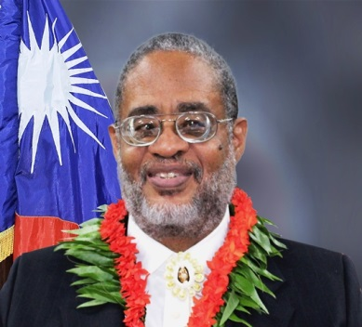The High Court is the highest court at the trial level. It is a superior court of record having general jurisdiction over controversies of law and fact in the Marshall Islands. The High Court has original jurisdiction over all cases properly filed with it, appellate jurisdiction over cases originally filed in subordinate courts, and, unless otherwise provided by law, jurisdiction to review the legality of any final decision of a government agency.

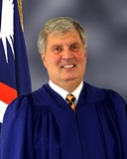The High Court currently consists of a chief justice and one associate justice: in 2017, Chief Justice Carl B. Ingram and Associate Justice Colin Winchester. Both are law-trained attorneys, as have been all prior High Court judges, and both attend at least one professional development seminar or workshop each year. Chief Justice Ingram was appointed to a second ten-year term commencing in October 2013. Associate Justice Colin Winchester was appointed to a two-year term commencing in November 2016, with an option for a second two years. Although the current High Court justices are United States citizens, Chief Justice Ingram has lived and worked in the Marshall Islands since 1979.

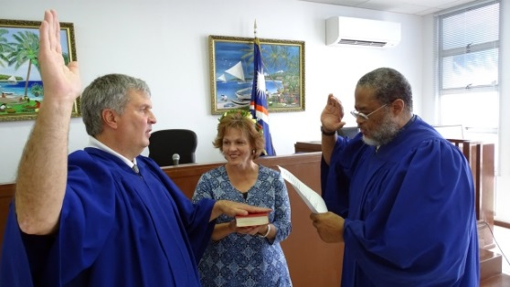During the 35 years the RMI Judiciary has been in operation, one Marshallese attorney has served on the High Court bench. He served for over six years, attaining the position of chief justice. Although highly respected, he left to become a member of the parliament, the Nitijela, and then private practice.

In addition to the two justices, the High Court is served by a chief clerk of the courts, a deputy chief clerk of the courts, and two assistant clerks. The High Court’s 2017 case statistics for civil cases, probate cases, criminal cases, juvenile cases, and caseloads are set forth below.

### 1. Civil Cases (other than Probate Cases)

The High Court’s 2017 statistics for civil cases (other than probate cases) cover the following:

* the number and nature of cases filed;
* the annual clearance rate and the five-year trend;
* the percentage of cleared cases cleared within 120 days and within 24 months in 2017;
* the average age of cleared cases at the end of the year and the five-year trend;
* the average age of pending cases at the end of the year and the five-year trend;
* the percentage of cleared cases appealed and the percentage of cases overturned on appeal; and
* affordability and accessibility in terms of fee waivers, low fees for vulnerable parties, cases heard on circuit, legal aid, and forms.

1. **Number and Nature of Cases Filed**

In 2017, plaintiffs and petitioners filed 337 new civil cases (other than probate cases) in the High Court: 297 in Majuro and 40 in Ebeye. This is 57 more cases than were filed in 2016.

The 297 civil cases filed in Majuro in 2017 breakdown as follows:

* Almost 77.10%, 229, involved family and personal status matters (including 101 customary adoptions, 42 guardianships, 30 citizenship cases, 24 divorce/child custody and support cases, 16 domestic violence cases seeking protection orders, 11 legal adoptions, 3 removal/deportation cases, and two civil confinement cases (regarding two men suffering from mental disorders);
* 23 commercial cases (17 collection cases, four corporate cases, one contract case, and one enforcement of foreign judgment case);
* 19 land cases (12 land rights cases and seven land rights and building cases);
* 15 admiralty/maritime cases; and
* 11 other cases (six tort cases, two employment cases, one election case, and two mandamus cases).

Of the 297 civil cases filed in Majuro in 2017, 233 were cleared in 2017, leaving 64 pending at the end of the year. The three largest categories of pending cases were as follows: 17 land or lease cases; 14 admiralty/maritime cases; and 10 commercial cases.

Of the 40 civil cases filed in Ebeye in 2017, 30 were customary adoptions, seven were collection cases, two were guardianships, and one was a divorce case. Of the 40 cases filed, 35 were cleared in 2017, leaving five pending at the end of the year: three collection cases, one customary adoption case, and one divorce case.

The High Court tracks the gender of plaintiffs and defendants. However, other than confirming that almost all child support cases and protection order cases are filed by women against men, the case numbers disaggregated by gender do not reveal any particular pattern or trend.

The High Court also tracks the disability status of litigants. As noted above, two men with mental disabilities were the subject of actions by the Government for civil confinement. Both cases were dismissed without the defendants being confined. The most common disability is difficulty walking. When litigants or witnesses cannot easily climb stairs, their cases are heard in a ground floor courtroom, and land rights cases, which involve older litigants and witnesses, are as a rule heard in a ground floor courtroom. Except as noted, disaggregation by disability status does not reveal any particular pattern.

Based upon this civil caseload, the High Court measures its efficiency in terms of the annual clearance rates, time standards, the age of cleared cases, and the age of pending cases.

1. **Annual Clearance Rate and the Five-Year Trend**

The High Court’s clearance goal is to achieve an annual clearance rate of 100%, or better. In 2017, however, the High Court did not meet its goal. The clearance rate for civil cases was only 93.46%: 314 cases were cleared and 337 were filed.

As the table and chart below show, the High Court has met its goal in four of the past five years. The drop of the clearance rate from 143.06% in 2014, to 101.16% in 2015, and to 93.46% in 2017 is the result of the Court’s successful backlog reduction policy. In the near term, the High Court expects its annual clearance rate to fluctuate around 100%. Also, the lower clearance rate and higher number of cases in 2017 results from an influx of non-resident corporation cases.

|  |  |  |  |  |  |  |
| --- | --- | --- | --- | --- | --- | --- |
| **Annual Clearances Rates for High Court Cases Cleared 2013 to 2017** | | | | | | |
|  | **2013** | **2014** | **2015** | **2016** | **2017** | **Avg.** |
| **Cases Filed** | 281 | 281 | 258 | 280 | 337 | 287.40 |
| **Cases Cleared** | 404 | 402 | 261 | 282 | 314 | 332.80 |
| **Clearance Rate** | 143.77% | 143.06% | 101.16% | 100.71% | 93.46% | 115.80% |
| **Annual Goal: 100%** | 100.00% | 100.00% | 100.00% | 100.00% | 100.00% | 100.00% |

**c. Time Standard: Percentage of Cleared Cases Cleared in 120 Days and in 24 Months**

In 2017, the High Court sought not only to meet its clearance goal but also to meet its time standard goal to clear 70% of its resolved civil cases within 120 days and 90% within 24 months. The High Court met it time standards for general civil cases. The High Court cleared 83.76% (263/314) of cleared civil cases within 120 days and 96.60% (303/314) within 24 months. As shown below, successfully meeting time standards has led to a reduction in the average age of cleared cases.

**d. Average Age of Cleared Cases at the End of the Year and the Five-Year Trend**

In 2017, the average age of cleared cases was 140.14 days. The table and chart below show that, over the past five years, the average age of cleared cases has come down and flattened out. This is due to the Court’s backlog reduction policy.

|  |  |  |  |  |  |
| --- | --- | --- | --- | --- | --- |
| **Average Age of High Court Civil Cases Cleared 2013-2017** | | | | | |
|  | **2013** | **2014** | **2015** | **2016** | **2017** |
| **Number of Cleared Cases** | 404 | 402 | 261 | 282 | 314 |
| **Average Age in Days** | 664.74 | 595.35 | 224.13 | 164.88 | 140.14 |
| **Average Age of Middle 75%** | 481.99 | 400.18 | 66.79 | 45.93 | 49.38 |
| **Median Age in Days** | 58.50 | 35.00 | 11.00 | 7.00 | 8.00 |

Just as the average age of cleared cases has gone down in 2017, so also has the average age of pending cases.

**e. Average Age of Pending Cases at the End of the Year and the Five-Year Trend**

In 2017, the number of pending cases went up considerably from 97 in 2016 to 120 in 2017. However, the age of pending continued to drop: from 1,303.62 days in 2016 to 1,029.18 in 2017. This is the result of the High Court’s successful backlog reduction project. Older cases are being cleared, and the High Court has reached a point where it can resolve about as many cases as come in. As the table and chart below show, since 2014 the number of pending cases has remained flat. Of the 120 cases pending at the end of 2017, about 50% were land cases and 25% were complex corporate and maritime cases. The Traditional Rights Court and the High Court are trying hard to resolve the land cases.

|  |  |  |  |  |  |
| --- | --- | --- | --- | --- | --- |
| **Average Age of Pending High Court Cases 2012-2017** | | | | | |
|  | **2013** | **2014** | **2015** | **2016** | **2017** |
| **Number of Pending Cases** | 223 | 103 | 99 | 97 | 120 |
| **Average Age in Days** | 1,515.52 | 1,569.88 | 1,368.81 | 1,303.62 | 1,029.18 |
| **Average Age of Middle 75%** | 1,364.58 | 1,376.09 | 1,182.38 | 1,086.99 | 798.11 |
| **Median Age in Days** | 1,002.00 | 1,017.00 | 633.00 | 544.00 | 296.00 |
| **% Reduction in Pndg Cases** | 36.65% | 53.81% | 3.88% | 2.02% | -23.71% |

**f. Appeals**

In addition to measuring efficiency, it is important to review the quality of judgments. Courts can measure the quality of their judgments in two ways: the percentage of cleared cases appealed and the percentage of cases overturned on appeal.

In 2017, the number and percentage of High Court civil cases appealed remained low. There were five cases appealed to the Supreme Court (note: for purposes of this calculation the RMI Judiciary add the number of writs to the appeals). That is, six appeals versus 314 cases cleared in the High Court, or 1.91%. Below is a table and chart showing the number of cleared cases appealed versus cleared cases not appealed over the past five years.

|  |  |  |  |  |  |  |
| --- | --- | --- | --- | --- | --- | --- |
| **Cleared High Court Civil Cases Not Appealed v. Appealed 2013-2017** | | | | | | |
|  | **2013** | **2014** | **2015** | **2016** | **2017** | **Avg.** |
| **Cases Cleared** | 404 | 402 | 261 | 282 | 314 | 332.60 |
| **Cases Appealed** | 2 | 4 | 4 | 2 | 6 | 3.60 |
| **Cases Not Appealed** | 402 | 398 | 257 | 280 | 308 | 329.00 |

In 2017, no High Court civil cases from 2017, or from previous years, were overturned on appeal. The percentage of cases overturned on appeal was 0%.

**g. Affordability and Accessibility: Fee Waivers; Cases Heard on Circuit; Legal Aid; and Forms**

It is not enough that courts be efficient and that the quality of judgments be high. The courts must be affordable and accessible. Affordability and accessibility to justice may be measured in terms of the availability of fee waivers, lower fees for vulnerable parties, the number of cases heard on circuit, the availability of free legal service, and the availability of forms.

* By rule and statute, fee waivers are available upon a showing of need. In 2017, the High Court continued to aggressively published fee waiver rules, however, no one requested a fee waiver in a High Court civil case.
* The filing fee for most types of High Court civil cases remained low: only $25. And in 2016, the filing fee for child custody and support cases (usually filed by single mothers) was reduced from $25 to $5. To off-set the low fees for most users, fees for admiralty cases, enforcement of foreign judgments, non-resident corporate cases, international adoptions, and citizenship cases are substantially higher.
* In 2017, a number of High Court cases were heard on the Ebeye circuit. Of the 337 civil cases filed in 2017, 40 cases (11.87%) were Ebeye circuit cases. Of the 314 civil cases cleared in 2017, 39 cases (12.42%) were Ebeye circuit cases.
* In 2017, the use of free legal services remained high. In 229 of the 337 civil cases filed in 2017 (67.95%), at least one of the parties was represented by the Micronesian Legal Services Corporation or the Office of the Public Defender, both of which provide legal assistance for free. Also in 2017, 10 potential plaintiffs were assigned a free court-appointed attorney for their claims. For FY 2017, the Nitijela appropriated $15,000 to the RMI Judiciary to pay court-appointed attorneys to represent those who cannot afford an attorney and for conflict reasons cannot use the Micronesian Legal Services Corporation or the Office of the Public Defender. The RMI Judiciary collected another $27,000 in FY 2017 for the court-appointed attorneys from private counsel who wished to opt-out of taking court-appointed cases.
* The RMI Judiciary has long used forms in small claims cases, name-change petitions, and guardianship cases. Since 2013, the RMI Judiciary has posted forms on its website for confirmation of customary adoptions, name-change petitions, fee and cost waivers, domestic-violence temporary protection orders, guardianship petitions, and small claims cases.

### 2. Probate Cases

Set forth below are the High Court’s 2017 case statistics for probate cases, covering:

* the number of probate cases;
* the annual clearance rate and the five-year trend;
* the percentage of cases cleared within 90 days;
* the average age of cleared cases at the end of the year and the five-year trend;
* the average age of pending cases at the end of the year and the five-year trend;
* the percentage of cleared cases appealed and the percentage of cases overturned on appeal; and
* affordability and accessibility in terms of fee waivers, low fees for smaller cases, cases heard on circuit, and legal aid.

**a. Number of Probate Cases**

Ten probate cases were filed in 2017, one more than in 2015 and 2016. Nine cases were filed in Majuro, and one was filed in Ebeye.

The High Court’s probate statistics disaggregated by gender do not reveal a pattern or trend. And in 2017 none of the probate petitioners or objectors were a disabled person.

1. **Annual Clearance Rate and the Five-Year Trend**

In 2017, the High Court cleared eight of the 10 probate cases filed in 2017, for a clearance rate of 80%. Since the backlog in probate cases has been eliminated, the High Court’s goal for probate cases is to maintain an average annual clearance rate of 100% over five years. As the table and chart below show, the High Court has achieved its goal. The average annual clearance rate over the past five years is 113.27%. Given the relatively low number of probate cases filed each year, the annual clearance rate should fluctuate around 100%.

|  |  |  |  |  |  |  |
| --- | --- | --- | --- | --- | --- | --- |
| **Annual Clearance Rates for High Court Probate Cases 2013-2017** | | | | | | |
|  | **2013** | **2014** | **2015** | **2016** | **2017** | **Avg.** |
| **Cases Filed** | 11 | 8 | 9 | 9 | 10 | 9.40 |
| **Cases Cleared** | 15 | 12 | 8 | 10 | 8 | 10.60 |
| **Clearance Rate** | 136.36% | 150.00% | 88.89% | 111.11% | 80.00% | 113.27% |
| **Clearance Rate Goal** | 100% | 100% | 100% | 100% | 100% | 100% |

**c. Time Standard: Percentage of Cleared Cases Cleared within 90 Days of the Date Filed**

In additional to the goal of an average annual clearance rate of 100% over five years, the High Court seeks to clear 90% of cleared probate cases within 90 days. Of the eight probate cases cleared in 2017, the High Court was able to clear the seven, 87.5%, within 90 days. The one cleared 2017 case not cleared within 90 days was cleared in 99 days. Two 2017 probate cases were cleared in early 2018.

**d. Average Age of Cleared Cases at the End of the Year and the Five-Year Trend**

The average age of the 8 probate cases cleared in 2017 was 62.25 days. Unless an objection is filed, most probate cases are cleared within seven to 11 weeks of filing, *i.e.*, within 49 to 77 days. Below is the five-year trend for the average age of cleared probate cases. It shows that after clearing out its backlog in 2013 and 2014, the High Court is achieving its goal of clearing probate cases within 77 days, absent the filing of an objection to the petition.

|  |  |  |  |  |  |
| --- | --- | --- | --- | --- | --- |
| **Average Age of Cleared High Court Probate Cases 2013-2017** | | | | | |
|  | **2013** | **2014** | **2015** | **2016** | **2017** |
| **Cases Cleared** | 15 | 12 | 8 | 10 | 8 |
| **Avg. Age of Cleared Cases** | 732.87 | 1,507.75 | 58.75 | 81.10 | 62.25 |

**e. Average Age of Pending Cases at the End of the Year**

At the end of 2017, two probate matters were pending: one filed on November 1, 2017, and the other filed on December 27, 2017. The average of the two pending cases at the end of 2017 was 32 days. Both were cleared in early 2018.

**f. Appeals**

In 2017, no cleared probate cases were appealed, nor were any cases from previous years overturned on appeal. Accordingly, the percentage of cleared probate cases appealed was 0%, and the percentage of appealed probate cases overturned on appeal was 0%. This has been the case for more than the past five years.

**g. Affordability and Accessibility: Fee Waivers; Low Fees, Cases Heard on Circuit; and Legal Aid**

As noted above, affordability and accessibility to justice can be seen in the availability of fee waivers, low fees for smaller cases, the number of cases heard on circuit, and the availability of free legal service.

* As with other civil cases, fee waivers are available in probate cases. However, in 2017 (as in recent years) no one requested a fee waiver in a probate case. In 2017, the High Court widely published notice of the waivers.
* In 2017, the fees for probate cases remained low. The filing fee for probate cases is $25, $100 for estates over $7,000.
* Of the 10 probate cases filed in 2017, one was an Ebeye circuit case (10.0%). Of the eight probate cases cleared in 2017, none were Ebeye circuit cases (0.0%).
* In four of the 10 probate cases filed in 2017 (40%), the petitioner was represented by the Micronesian Legal Services Corporation (MLSC).  This figure is a little lower than in previous years. In 2017 there were more large probate cases, where the petitioner retained private counsel.

### 3. Criminal Cases

Set forth below are the High Court’s 2017 case statistics for criminal cases. These statistics cover the following:

* the number and nature of criminal cases;
* the annual clearance rate and the five-year trend;
* the percentage of cleared cases cleared within eighteen months;
* the average age of cleared cases at the end of the year and the five-year trend;
* the average age of pending cases at the end of the year;
* the percentage of cleared cases appealed and the percentage of cleared cases overturned on appeal; and
* affordability and accessibility (low or no fees, fee waivers, cases heard on circuit, and legal aid).

**a. Number and Nature of Cases**

In 2017, the Office of the Attorney-General filed 29 criminal cases in the High Court: 23 in Majuro and six in Ebeye. This is 11 more than in 2016.

The 23 criminal cases filed in Majuro in 2017 breakdown (by most serious offense charged) as follows: one murder; one aggravated arson; nine aggravated assaults; four sexual assaults; one burglary; one official oppression; one assault with a deadly weapon; one criminal mischief; one reckless endangerment; one theft by unlawful taking; one negligent driving; and one reckless burning. In the 23 Majuro cases, two of the defendants were women. None of the defendants were disabled persons.

The six felony cases filed in Ebeye in 2017 breakdown (by most serious offense charged) as follows: three aggravated assaults; one sexual assault; two burglaries; and one assault. In the six Ebeye cases, none of the defendants was a woman or a disabled person.

Of the 23 Majuro cases, females were the victims in 11 cases: one murder; four sexual assaults; three aggravated assaults; one negligent driving; and two reckless burnings. In the six Ebeye cases, women were the victims in three cases: sexual assault; assault; and burglary/theft. Counseling for victims of domestic violence and sexual violence is available through NGOs, including Youth-to-Youth in Health and Women United Together Marshall Islands.

Other than as noted above, the High Court’s criminal case statistics, disaggregated by gender or disability, do not reveal any pattern or trend.

**b. Clearance Rates**

The High Court’s clearance goal for criminal cases is an annual clearance rate of 100%, or better. In 2017, the High Court cleared 25 criminal cases from all years, four less than the number of cases filed in 2017, resulting in a 2017 clearance rate of only 86.21% (25/29).

As the chart below shows, the five-year average for the annual clearance rates is above 100%, at 121.96%. In three of the five years the clearance rate was 100% or better.

|  |  |  |  |  |  |  |
| --- | --- | --- | --- | --- | --- | --- |
| **Annual Clearance Rates for High Court Criminal Cases 2013-2017** | | | | | | |
|  | **2013** | **2014** | **2015** | **2016** | **2017** | **Avg.** |
| **Cases Filed** | 16 | 18 | 18 | 18 | 29 | 19.8 |
| **Cases Cleared** | 18 | 40 | 18 | 16 | 25 | 23.4 |
| **Clearance Rate** | 112.50% | 222.22% | 100.00% | 88.89% | 86.21% | 121.96% |
| **Annual Goal** | 100.00% | 100.00% | 100.00% | 100.00% | 100.00% | 100.00% |

**c. Time Standard: Percentage of Cleared Cases Cleared Within 18 Months**

In addition to the annual clearance rate, the High Court seeks to clear 90% of the cleared criminal cases within 18 months of the date filed. In 2017, the High Court cleared 23 of the 25 cleared cases (92%) within 18 months.

**d. Average Age of Cleared Cases**

The average age of the 25 High Court criminal cases cleared in 2017 was 202.76 days, down slightly from 203.56 days in 2016. The number of High Court criminal cases cleared in the past five years (2013-2017) and the average duration of cleared cases are as shown below. The high average age of cases cleared in 2014 is the result of clearing very old and abandoned cases. The relatively low average of 220.67 days in 2015, 203.56 days in 2016, and 202.76 days in 2017 is closer to what the High Court believes should be the norm.

|  |  |  |  |  |  |
| --- | --- | --- | --- | --- | --- |
| **Average Age of High Court Criminal Cases Cleared 2013-2017** | | | | | |
|  | **2013** | **2014** | **2015** | **2016** | **2017** |
| **Cases Cleared** | 18 | 40 | 18 | 16 | 25 |
| **Avg. Age of Cases Cleared** | 250.00 | 1,456.15 | 220.67 | 203.56 | 202.76 |

**e. Average Age of Pending Cases**

By the end of 2017, 14 criminal cases remained pending: up four from the end of 2016. However, the average age of the pending cases was only 139 days: down from 221.40 days at the end of 2016. The High Court has encouraged the prosecutors and defense counsel to resolve older criminal cases, particularly cases older than 365 days. At the end of 2017, only one of the remaining 14 cases were more than 365 days old. In that case, the defendant fled the Republic.

**f. Appeals**

As an indication of the quality of High Court criminal decisions, in 2017 no High Court criminal cases were appealed. Accordingly, the percentage of cases appealed was 0.0%. Also, no cases were overturned on appeal. The percentage of appealed criminal cases overturned on appeal was 0.0%. This is consistent with results from the past five years.

**g. Affordability and Accessibility: No Fee or Fee Waivers; Cases Heard on Circuit; and Legal Aid**

The RMI Judiciary seeks to ensure its users affordability and accessible criminal justice through the absence of fees and the availability of fee waivers, circuit court sessions, and free legal representation.

That is, the RMI Judiciary does not impose fees or court costs on criminal defendants at the trial level. And on appeal, a defendant may apply for waiver of the filing fee and transcript costs.

More serious felony cases are heard on circuit with a High Court justice and clerk traveling from Majuro to the island where the crime allegedly occurred. Of the 29 criminal cases filed in 2017, six cases (20.69%) were Ebeye circuit cases. Of the 25 criminal cases cleared in 2017, eight cases (32%) were Ebeye circuit cases.

Finally, criminal defendants have access to free legal counsel. In 2017, as in other years, most criminal defendants were represented by the Office of the Public Defender or the Micronesian Legal Services Corporation. In 2017, the defendants received legal assistance at no cost from the Office of the Public Defender in all but two cases. In those two cases, the defendants fled the Republic before being brought before the Court. The high use of free counsel in criminal cases is typical of most years.

### 4. Juvenile Cases

Set forth below are the High Court’s 2017 case statistics for juvenile cases. These statistics cover the following:

* the number of juvenile cases filed;
* the annual clearance rate;
* the percentage of cleared cases cleared within 90 days;
* the average age of cleared cases by the end of the year;
* the percentage of cleared cases appealed and the percentage of cleared cases overturned on appeal; and
* affordability and accessibility (no or low fees, fee waiver available, cases heard on circuit, and legal aid).

**a. Number of Cases**

In 2017, the Office of the Attorney-General filed one juvenile case in the High Court. That case is a double homicide and sexual assault. The trial commenced late 2017 and was concluded in early February 2018.

Since 2006, when the Republic filed seven juvenile cases in Majuro, the Republic has filed no more than four High Court juvenile cases in a year. Most juvenile cases (underage drinking) are heard by the District Court, not the High Court. Almost all juvenile offenders are boys. None of the juveniles has been identified as disabled.

**b. Clearance Rate**

As noted above, only one juvenile case was filed in the High Court in 2017. No other juvenile cases were pending in 2017, and so none were cleared. If the number of juvenile cases were to increase, the High Court’s clearance goal would be 100%. That is, in any one year the High Court would try to clear as many cases are were filed.

**c. Time Standard: Percentage of Cleared Cases Cleared within Six Months**

In addition to the goal of achieving a 100% clearance rate, the High Court seeks to clear 80% of juvenile cases within six months of filing. However, as noted above, in 2017 only one juvenile case was filed and pending. That case was a very serious and complex case. As of December 31, 2017, the case had been pending 158 days since July 26, 2017. The case was completed in early February 2018 and is now on appeal.

**d. Average Age of Cleared Cases**

As a result of the low number of juvenile cases being filed in the High Court, there is no meaningful average age of cleared cases for 2017, for the five-year trend report, or cleared within six months.

**e. Appeals**

In 2017, no High Court juvenile cases were appealed, nor were any cases from previous years overturned on appeal. Accordingly, the percentage of juvenile cases appealed and the percentage of appealed juvenile cases overturned on appeal were 0%. This is consistent with results from past years. However, as noted above the one 2017 juvenile case cleared in 2018 was appealed.

**f. Affordability and Accessibility: Fee Waivers; Cases Heard on Circuit; and Legal Aid**

To ensure accessibility to justice, the RMI Judiciary does not impose fees or court costs on juvenile offenders at the trial level. On appeal, a juvenile offender may apply for a fee waiver.

Also, High Court juvenile cases are heard on circuit and juvenile offenders have access to free legal counsel. The sole juvenile case filed in 2017 is a Majuro case. In that case, the juvenile offender was represented by the Office of the Public Defender. This has been the case for almost all juvenile cases for more than the past five years.

### 5. Caseloads for Judges and Clerks

The total number of all High Court cases filed in 2017 was 337, 57 more than in 2016. For the two High Court Justices, this equates to an average caseload of 188.50 new cases in 2017. These figures are consistent with recent years, although the figures fluctuate:

* for 2017, 188.50 cases per justice;
* for 2016, 153.50 cases per justice;
* for 2015, 143.50 cases per justice;
* for 2014, 155.00 cases per justice; and
* for 2013, 156.00 cases per justice.

Generally, cases are assigned between the two judges on an alternating basis.

For the five clerks that regularly process High Court cases, their 2017 caseload included 75.40 new cases per clerk. As with the justices, the clerks’ caseloads fluctuate from year-to-year within a limited range:

* For 2017, 75.40 cases per clerk;
* for 2016, 61.40 cases per clerk;
* for 2015, 57.40 cases per clerk;
* for 2014, 62.00 cases per clerk; and
* for 2013, 62.40 cases per clerk.

There is some specialization among the clerks, but all clerks handle most functions.

|  |  |  |  |  |  |
| --- | --- | --- | --- | --- | --- |
| **Average Caseload for High Court Justices and Clerks 2013-2017** | | | | | |
|  | **2013** | **2014** | **2015** | **2016** | **2017** |
| **Cases per Judge** | 156.00 | 155.00 | 143.50 | 153.50 | 188.50 |
| **Cases per Clerk** | 62.40 | 62.00 | 57.40 | 61.40 | 75.40 |

### 6. Selected Decisions

Selected High Court decisions can be found on the RMI Judiciary’s website, [http://rmicourts.org/](http://rmicourts.org/,), under the heading Court Decisions and Digests. The selected cases are the noteworthy ones; ones that the RMI Judiciary believes should be published for the benefit of the public and practitioners. The High Court will not publish a case unless it satisfies one or more of the following standards: (1) the opinion lays down a new rule of law, or alters, modifies an existing rule, or applies an established rule to a novel fact situation; (2) the opinion involves a legal issue of continuing public interest; (3) the opinion directs attention to the shortcomings of existing common law or inadequacies in statutes; (4) the opinion resolves an apparent conflict of authority. Most High Court decisions are routine in nature and generally are of interest only to the parties. The public can get copies of these decisions upon request to the Clerk of the Courts.

## C. Traditional Rights Court

Supporting the High Court at the trial level is the Traditional Rights Court (“TRC”). The TRC is a special-jurisdiction court of record consisting of three or more judges appointed for terms of four to ten years, not to exceed age 72, and selected to include a fair representation of all classes of land rights: Iroijlaplap (high chief); where applicable, Iroijedrik (lower chief); Alap (head of commoner/worker clan); and Dri Jerbal (commoner/worker).

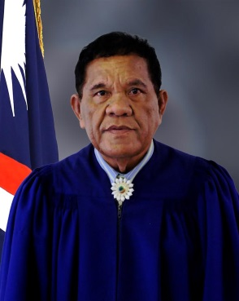In June 2010, the Cabinet appointed Chief Judge Walter K. Elbon (alap member) and Associate Judge Grace L. Leban (dri jerbal member) for terms of 10 years. In April 2013, the Cabinet appointed Nixon David (iroij member) for a 4-year term, and in March 2017 reappointed Judge David for a second four-year term. All TRC judges are lay judges who receive specialized training.

One of the three TRC judges, Judge Leban, is a woman, the first woman to be appointed as a full-time TRC judge. The RMI Judiciary is committed to increasing the number of female judges. However, at the end of the year only three of the RMI Judiciary's approximately 30 judges were women: one Traditional Rights Court judge; and two Community Court judges.

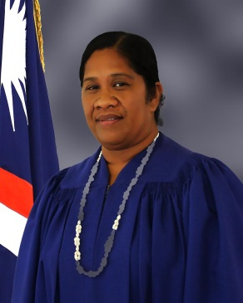The jurisdiction of the TRC is limited to questions relating to titles to land rights or other legal interests depending wholly or partly on customary law and traditional practices. The jurisdiction of the TRC may be invoked as of right upon application by a party to a pending High Court proceeding, provided the High Court judge certifies that a substantial question has arisen within the jurisdiction of the TRC.

Customary law questions certified by the High Court are decided by the TRC panel and reported back to the High Court. Upon request by the TRC’s presiding judge, a party, or the referring High Court judge, the Chief Justice of the High Court may appoint a High Court or District Court judge to sit with the TRC to make procedural and evidentiary rulings. In such joint-hearing cases, the High Court or District Court judge does not participate with the TRC in deliberations on its opinion, but the High Court or District Court judge may in the presence of the parties or their counsel answer questions of law or procedure posed by the TRC. The TRC’s jurisdiction also includes rendering an opinion on whether compensation for the taking of land rights in eminent domain proceedings is just.

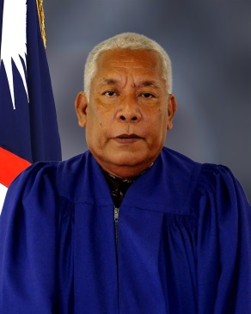The Constitution states that the High Court is to give decisions of the TRC substantial weight, but TRC decisions are not binding unless the High Court concludes that justice so requires. The Supreme Court has held the High Court is to review and adopt the TRC’s findings unless the findings are clearly erroneous or contrary to law.

In 2017, the TRC issued two decisions, six less decisions than in 2016. As of June 29, 2018, the TRC has issued three decisions, and a decision is due in July 2018. Twenty-five land cases are pending before the TRC and another seven cases (in the High Court) are pending the outcome of land cases. In the second half of 2018 and the first quarter of 2019, the TRC has five cases set for trial.

The TRC’s decisions can be found on the RMI Judiciary’s website, [http://rmicourts.org/](http://rmicourts.org/,), under the heading Court Decisions and Digests.

## D. District Court

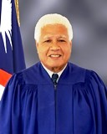In addition to the TRC, the District Court is below the High Court at the trial level. The District Court is a limited-jurisdiction court of record. It consists of a presiding judge and two associate judges appointed for 10-year terms, not to exceed age 72. In 2017, the three incumbent judges were Presiding Judge Milton Zackios, Associate Judge A. Tarry Paul, and Associate Judge Davidson T. Jajo (Ebeye). Their 10-year terms expire in 2018, 2025, and 2026, respectively.

The current District Court judges are lay judges who receive specialized training. The District Court has original jurisdiction concurrent with the High Court

1. in civil cases where the amount claimed or the value of the property involved does not exceed $10,000 (excluding matters within the exclusive jurisdiction of the High Court by Constitution or statute, such as land title cases and admiralty and maritime matters) and
2. in criminal cases involving offenses for which the maximum penalty does not exceed a fine of $4,000 or imprisonment for a term of less than three years, or both.

The District Court also has appellate jurisdiction to review any decision of a Community Court.

The District Court’s 2017 case statistics and case workload are set forth below.

### 1. Traffic Cases (Majuro)

The District Court’s 2017 statistics for Majuro traffic cases cover the following:

* the number and nature of cases filed in 2017;
* the annual clearance rates for the most recent five years;
* the average duration of cleared cases for the most recent five years;
* the percentage of cases appealed and the percentage of appealed cases overturned on appeal; and
* affordability and accessibility in terms of fee waivers, cases heard outside of Majuro (the Capital), legal aid, and forms.

**a. Number and Nature of Cases Filed**

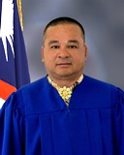In 2017, the National Police and Majuro Atoll Local Government Police prosecutors filed in the District Court a total of 1,021 traffic cases in Majuro. Of the 1,021 traffic cases, a total of 225 cases involved DUI/Drunken Driving.

Of the 1,021 traffic cases filed in Majuro in 2017, 873 were cleared in 2017, leaving 148 pending at the end of the year. Some cases are delayed because the defendants gave false addresses or have fled the Republic for the United States or have fled Majuro for the outer islands.

**b. Clearance Rates**

The District Court’s efficiency can be measured by case clearance rates. The District Court’s 2017 annual clearance rate for traffic cases was 98% (finalized/filed). During 2017, the District Court, counsel, and parties closed 873 2017 cases and 125 cases from previous years (2015-2016). And as noted above, the government filed 1,021 new cases in 2017. The District Court’s goal is to maintain an annual clearance rate for traffic cases of 100% or better, for each year. As a result of its efforts to process cases without undue delay, the District Court was able to gradually increase its clearance rate as shown below.

The District Court each month dismisses without prejudice abandoned cases that have been pending six months or more.

**c. Average Duration of Traffic Cases Cleared**

The average duration of District Court traffic cases cleared in 2017 was 55 days. A total of 873 2017 cases, 98 2016 cases, and 25 2015 case were cleared in 2017. Excluding cases from earlier years cleared in 2017, the average duration of 2017 traffic cases cleared in 2017 is only 15 days.

For Majuro District Court traffic cases filed in the five years (2013-2017), the average durations of cleared cases in days were as follows:

**d. Appeals**

In addition to measuring efficiency, it is important to review the quality of judgments. The quality of judgments can be measured in two ways: the percentage of cases appealed and the percentage of appealed cases overturned on appeal.

In 2017, none of the 998 District Court traffic cases cleared in 2017 were appealed to the High Court. Similarly, in 2013, 2014, 2015, and 2016 no traffic cases were appealed.

Furthermore, in 2017, there were no District Court traffic cases or decisions overturned from any year on appeal.

**e. Affordability and Accessibility: Fee Waivers; Cases Heard Outside of Majuro; Legal Aid; and Forms**

As noted earlier, it is not enough that courts be efficient and that the quality of judgment be high. The courts must be affordable and accessible. Affordability and accessibility to justice may be measured in terms of the availability of fee waivers, the number of cases heard outside of the capital Majuro, the availability of free legal service, and the availability of forms.

**(i) Fee Waivers**

As there are no filing fees for traffic cases, fee waivers are not applicable.

**(ii) Cases Heard on Ebeye**

A third District Court judge is stationed in Ebeye to handle District Court matters including traffic cases filed there.

**(iii) Free Legal Services**

At the District Court level, most traffic offenders are self-represented. Only in more serious cases, such as those involving DUI, do they seek legal assistance and representation by the Micronesian Legal Services Corporation or the Office of the Public Defender, which both provide free legal assistance. Of the 1,021 traffic cases filed in 2017, only 165 defendants (16.2%) were represented by the Office of the Public Defender, 852 represented themselves (83.4%), and 4 were represented by private counsel (0.4%).

**(iv) Forms**

Consent judgment forms are available at the Clerk’s Office for traffic offenders who wish to plead guilty and pay a fine. Those who use the form do not have to appear in court.

### 2. Criminal Cases (Majuro)

The District Court’s 2017 statistics for Majuro criminal cases cover the following:

* the number and nature of cases filed in 2017;
* the annual clearance rates for the most recent five years;
* the average duration of cleared cases in the most recent five years;
* the percentage of cases appealed and the percentage of appealed cases overturned on appeal; and
* accessibility in terms of fee waivers, cases heard outside of Majuro, legal aid, and forms.

**a. Number and Nature of Cases Filed**

In 2017, the National Police and Majuro Atoll Local Government Police prosecutors filed in the District Court a total of 783 criminal cases in Majuro.

Of the 783 criminal cases, 705 were cleared in 2017, leaving 78 pending at the end of the year. The 78 cases remained pending due to serious nature, to police having difficulty locating defendants who either relocated to the United States, or to the outer islands of the Republic or gave false addresses.

**b. Clearance Rates**

The District Court’s 2017 annual clearance rate for criminal cases was 96%. During 2017, the District Court, counsel, and parties closed 705 2017 cases and 50 cases from 2016. As noted above, the government filed 783 new cases in 2017. The District Court’s goal is to maintain an annual clearance rate for criminal cases of 100% or better, for each year.

**c. Average Duration of Cleared Criminal Cases**

In addition to annual clearance rates, the efficiency of a case management system can be measured by the age of cleared cases. The average duration of District Court criminal cases cleared in 2017 was 30 days. Excluding the 50 cases from 2016 cleared in 2017, the average duration of 2017 criminal cases cleared in 2017 is only 17 days.

.

**d. Appeals**

In addition to measuring efficiency, it is important to review the quality of judgments. The quality of judgments can be measured in two ways: the percentage of cases appealed and the percentage of appealed cases overturned on appeal.

In 2017, none of the 755 District Court criminal cases cleared in 2017 were appealed to the High Court. Similarly, in 2013, 2014, 2015, and 2016 no criminal cases were appealed. Also in 2017, there were no District Court criminal cases or decisions from any years overturned.

**e. Affordability and Accessibility: Fee Waivers; Cases Heard Outside of Majuro; Legal Aid; and Forms**

The courts must be affordable and accessible. Affordability and accessibility to justice may be measured in terms of the availability of fee waivers, the number of cases heard outside of the capital Majuro, the availability of free legal service, and the availability of forms.

**(i) Fee Waivers**

As there are no filing fees for criminal cases, fee waivers are not applicable.

**(ii) Cases Heard on Ebeye**

A third District Court judge is stationed in Ebeye to handle District Court matters including criminal cases filed there.

**(iii) Free Legal Services**

At the District Court level, most defendants are self-represented. Only in more serious cases, such as those involving selling alcohol to minors and assault and battery, do defendants seek legal assistance and representation by the Micronesian Legal Services Corporation or the Office of the Public Defender, which both provide free legal assistance. Of the 783 criminal cases filed in 2017, 19 defendants (2.43%) were represented by the Office of the Public Defender, 763 represented themselves (97.44%), and one was represented by private counsel (0.13%).

**(iv) Forms**

Consent judgment forms are available at the Clerk’s Office for defendants who wish to plead guilty and pay a fine. Those who use the form do not have to appear in court.

### 3. Juvenile Cases (Majuro)

The District Court’s 2017 statistics for juvenile cases cover the following:

* the number and nature of cases filed in 2017;
* the annual clearance rates for the most recent five years;
* the average duration of cleared cases;
* the percentage of cases appealed and the percentage of cases overturned on appeal; and
* accessibility in terms of fee waivers, cases heard outside of Majuro, legal aid, and forms.

**a. Number and Nature of Cases Filed**

In 2017, the National Police and Majuro Atoll Local Government Police prosecutors filed in the District Court a total of 60 juvenile cases in Majuro. Twenty-one cases involved curfew violations, 22 involved underage drinking and alcohol related charges, eight cases involved traffic & DUI related charges, three involved littering chares, and six involved other cases[1].

Of the 60 juvenile cases filed in Majuro in 2017, 18 were cleared in 2017, leaving 42 pending at the end of the year. As of May 31, 2018, 11 cases have been cleared. Thirty one cases remain pending due to difficulty in bringing to court both the juvenile and parent(s).

**b. Clearance Rates**

The District Court’s efficiency in handling juvenile cases can be measured by case clearance rates. The District Court’s 2017 annual clearance rate for juvenile cases was 137%. During 2017, the District Court, counsel, and parties closed 18 cases from 2017 and 64 2016 cases. And as noted below, 60 new cases were filed in 2017. The District Court’s goal is to maintain an annual clearance rate for juvenile cases of 100% or better, for each year. As a result of its efforts to process cases without undue delay, the District Court was able to gradually increase its clearance rate as shown below.

The District Court each month dismisses without prejudice abandoned cases that have been pending six months or more.

**c. Average Duration of Cleared Juvenile Cases**

In addition to annual clearance rates, the efficiency of a case management system can be measured by the age of cleared cases. The average duration of District Court juvenile cases cleared in 2017 was 278 days. Excluding the 64 cases from 2016 cleared in 2017, the average duration of 2017 juvenile cases cleared in 2017 is 165 days. This high figure is due to 10 of the juvenile cases cleared in 2017 being dismissed after 6 months or more due to the failure to prosecute.

**d. Appeals**

The quality of judgments can be measured in two ways: the percentage of cases appealed and the percentage of appealed cases overturned on appeal.

In 2017, none of the 82 District Court juvenile cases cleared in 2017 were appealed to the High Court. Similarly, in 2013, 2014, 2015, and 2016 no juvenile cases were appealed.

Furthermore, in 2017, there were no District Court juvenile cases or decisions from any years overturned on appeal.

**e. Affordability and Accessibility: Fee Waivers; Cases Heard Outside of Majuro; Legal Aid; and Forms**

The courts must be affordable and accessible. Affordability and accessibility to justice may be measured in terms of the availability of fee waivers, the number of cases heard outside of the capital Majuro, the availability of free legal service, and the availability of forms.

**(i) Fee Waivers**

As there are no filing fees for juvenile cases, fee waivers are not applicable.

**(ii) Cases Heard on Ebeye**

A third District Court judge is stationed in Ebeye to handle District Court matters including juvenile cases filed there.

**(iii) Free Legal Services**

At the District Court level, most juvenile offenders are self-represented. Only in more serious cases do they seek legal assistance and representation by the Micronesian Legal Services Corporation or the Office of the Public Defender, which both provide free legal assistance. Of the 60 juvenile cases filed in 2017, none were represented by private counsel (0%), 59 represented themselves (98%), and 1 was represented by the Office of the Public Defender (2%). Similarly in previous years, the number of juvenile offenders represented by the Office of the Public Defender or by private counsel has been very low. In 2016, only one juvenile offender was represented by private counsel and none were represented by the Office of the Public Defender.

**(iv) Forms**

Although consent judgment forms are available at the Clerk’s Office for offenders who wish to plead guilty and pay a fine, these forms are not applicable for juvenile matters as juvenile cases are treated differently. It is a requirement that all juvenile offenders must attend Court with the presence of a parent and counsel.

### 4. Small Claims Cases (Majuro)

The District Court’s 2017 statistics for Majuro small claims cases cover the following:

* the number and nature of cases filed in 2017;
* the annual clearance rates for the most recent five years;
* the average duration of cleared cases;
* the percentage of cases appealed and the percentage of cases overturned on appeal; and
* affordability and accessibility in terms of fee waivers, cases heard outside of Majuro, legal aid, and forms.

1. **Number of Cases Filed**

In 2017, a total of 159 small claims cases were filed in Majuro.

Of the 159 small claims cases filed in Majuro in 2017, 132 were cleared in 2017, leaving 27 pending at the end of the year. Cases that remained pending at the end of the year involved defendants who either reside in the outer islands, moved to the United States, or cannot be located.

**b. Clearance Rates**

The District Court’s 2017 annual clearance rate for small claims cases was 92.5%. During 2017, the District Court, counsel, and parties closed 132 2017 cases and 15 cases from previous years (2015-2016). And as noted below, 159 new cases were filed in 2017. The District Court’s goal is to maintain an annual clearance rate for small claims cases of 100% or better, for each year.

**c. Average Duration of Cleared Small Claims Cases**

In addition to annual clearance rates, the efficiency of a case management system can be measured by the age of cleared cases.

The average duration of District Court small claims cases cleared in 2017 was 55 days. A total of 132 2017 cases, 13 2016 cases, and 2 2015 cases were cleared in 2017. Excluding cases from earlier years cleared in 2017, the average duration of 2017 small claims cases cleared in 2017 is only 32 days.

For Majuro District Court small claims cases cleared in the past six years (2011-2016), the average duration of cleared cases in days were as follows:

**d. Appeals**

In addition to measuring efficiency, it is important to review the quality of judgments. The quality of judgments can be measured in two ways: the percentage of cases appealed and the percentage of appealed cases overturned on appeal.

In 2017, none of the 147 District Court small claims cases cleared in 2017 were appealed to the High Court. Similarly, in 2013, 2014, 2015, and 2016 no small claims cases were appealed.

Furthermore, in 2017, there was no District Court small claims cases or decisions from any years overturned on appeal.

**e. Affordability and Accessibility: Fee Waivers; Cases Heard Outside of Majuro; Legal Aid; and Forms**

It is not enough that courts be efficient and that the quality of judgment be high. The courts must be affordable and accessible. Affordability and accessibility to justice may be measured in terms of the availability of fee waivers, the number of cases heard outside of the capital Majuro, the availability of free legal service, and the availability of forms.

**(i) Fee Waivers**

Although, by rule and statute, fee waivers are available upon a showing of need, plaintiffs did not request a fee waiver in any of the 2017 District Court small claims cases. The filing fee for small claims cases remains low at only $5 dollars.

**(ii) Cases Heard on Ebeye**

A third District Court judge is stationed in Ebeye to handle District Court matters including small claims cases filed there.

**(iii) Free Legal Services**

At the District Court level, most plaintiffs and defendants in small claims cases are self-represented. Only in a few cases do defendants seek legal assistance and representation by the Micronesian Legal Services Corporation or the Office of the Public Defender, which both provide free legal assistance. Of the 159 small claims cases filed in 2017, only two of the defendants (1.26%) were represented by the Micronesian Legal Services Corporation or the Public Defender. All others appeared *pro se*.

**(iv) Forms**

Small claims forms are available on the court’s website ([www.rmicourts.org](http://www.rmicourts.org)) or at the Clerk’s Office.

In summary, a total of 2,023 cases were filed in the Majuro District Court: 1,021 traffic cases; 783 criminal and local government ordinance cases; 60 juvenile cases; 159 small claims cases; and no other civil cases.

5. Caseload for Judges and Clerks (Majuro)

In 2017, the average number of new cases heard by the two District Court judges in Majuro was 1011.5 cases, and the average number of new cases per court clerk was the same.

6. Ebeye

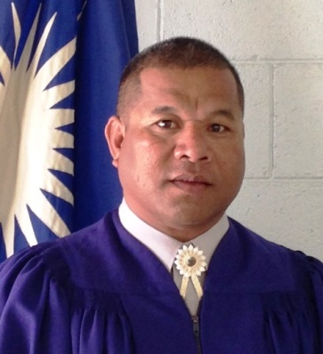In 2017 on Ebeye, 275 cases were filed in the District Court:

* 86 traffic cases (80 cleared and 6 pending);
* 0 criminal cases;
* 162 local government ordinance cases (156 cleared and 6 pending;
* 0 juvenile cases; and
* 27 small claim cases (27 cleared and 0 pending).

The average number of cases heard per District Court judge in Ebeye was 275, and the average number of cases per court clerk was 137.5.

No 2017 Ebeye District Court cases were appealed or overturned on appeal.

In all Ebeye District Court small claims cases, traffic cases, criminal and local government ordinance cases, the parties were self-represented. The Office of the Public Defender did not represent any of the defendants in any of the cases that were cleared in 2017.

## E. Community Courts

On the outer islands, the RMI Judiciary has Community Courts. A Community Court is a limited-jurisdiction court of record for a local government area, of which there are 24. Each Community Court consists of a presiding judge and such number of associate judges, if any, as the Judicial Service Commission may appoint. Appointments are made for terms of up to six years, but not to exceed age 72. Community Court judges are lay judges with limited training. A Community Court has original jurisdiction concurrent with the High Court and the District Court within its local government area:

(i) in all civil cases where the amount claimed or the value of the property involved does not exceed $1,000 (excluding matters within the exclusive jurisdiction of the High Court by Constitution or statute, such as land title cases and admiralty and maritime matters) and

(ii) in all criminal cases involving offenses for which the maximum penalty does not exceed a fine of $400 or imprisonment for a term not exceeding six months, or both.

At the end of 2017, there were 20 serving Community Court judges and 10 vacancies. At the date of this report, there are eight vacancies for which the Commission is waiting recommendations from local government councils: Arno (2); Enewetak (1); Lae (1); Lib (1); Namu (1); Rongelap (1); and unallocated (1).

Community court judges receive training when they come to Majuro for biennial summer conferences and on other occasions. The RMI Judiciary encourages all Community Court judges who are in Majuro for other business to stop by the courthouse and arrange for training opportunities with the District Court judges. In 2017, the RMI Judiciary held two workshops for Community Court judges. The RMI Judiciary intends to continue providing such trainings for Community Court judges. The next training is scheduled for August 2019.

## F. Travel to the Outer Islands and Ebeye

The RMI Judiciary also travels to the outer islands on an as-needed basis.

If the offices of the Attorney-General, the Public Defender, and the Micronesian Legal Services Corporation were to station attorneys on Ebeye full time, the Ebeye, the Ebeye caseload would increase and a third High Court justice would be necessary to help move the cases. Currently, the High Court travels to Ebeye once every quarter if cases are ready to proceed.

If the Government cannot afford to station attorneys full-time on Ebeye, the RMI Judiciary would request that at the very least the Office of the Attorney-General and Office of the Public Defender receive funding to employ trial assistants on Ebeye. This was the practice until relatively recently. Defendants brought before the District Court on Ebeye on criminal charges have a constitutional right to legal counsel. Late in 2014, MLSC reopened its Ebeye office and staffed it with a secretary.

## G. Other Services: Births, Deaths, Marriages, Notarizations, etc.

In addition to deciding cases, the courts help the people through confirming delayed registrations of births and death, performing marriages, notarizing and certifying documents, and issuing record checks. The courts offer these services on no or little notice. However, couples usually schedule marriages one to three days in advance. Marriages by non-citizens must first be approved by the Ministry of Foreign Affairs.

1. Majuro. In 2017 on Majuro, the High Court and the District Court processed 257 delayed registrations of birth, four delayed registrations of death, and performed 58 marriages. The clerks notarized 760 documents, of which 14 were notarized off site to accommodate disabled persons. Upon request, clerks will go to the hospital or homes to notarize documents for those who cannot travel to the courthouses. Also, the clerks issued 23 apostille certifications, 52 criminal record checks and 162 corporate litigation checks.

2. Ebeye. In 2017 on Ebeye, the District Court processed 98 delayed registrations of birth, no delayed registrations of death, and performed 6 marriages. The Ebeye clerks also notarized 214 documents, of which 7 were notarized off site.

The five-year totals for birth, deaths, marriages, and notarizations are as shown below.

|  |  |  |  |  |  |
| --- | --- | --- | --- | --- | --- |
| **Birth, Deaths, Etc. 2013-2017** | | | | | |
|  | **2013** | **2014** | **2015** | **2016** | **2017** |
| **Births** | 324 | 330 | 327 | 336 | 355 |
| **Deaths** | 13 | 1 | 2 | 5 | 4 |
| **Marriages** | 84 | 60 | 60 | 40 | 64 |
| **Notarizations** | 770 | 1,113 | 1,030 | 1,206 | 974 |
| **Apostille Cert’s** | 4 | 7 | 38 | 22 | 23 |
| **Criminal Checks** | 72 | 112 | 42 | 33 | 52 |
| **Corporate Checks** | 146 | 104 | 94 | 75 | 162 |

## H. Court Staff

In 2017, the RMI Judiciary’s staff included the following: a chief clerk of the courts, a deputy chief clerk of the courts, five assistant clerks (one in Ebeye), three bailiffs (seconded from the National Police), and one maintenance worker. The chief clerk and four of the six assistant clerks were women. A listing of the judiciary personnel is attached as Appendix 2.

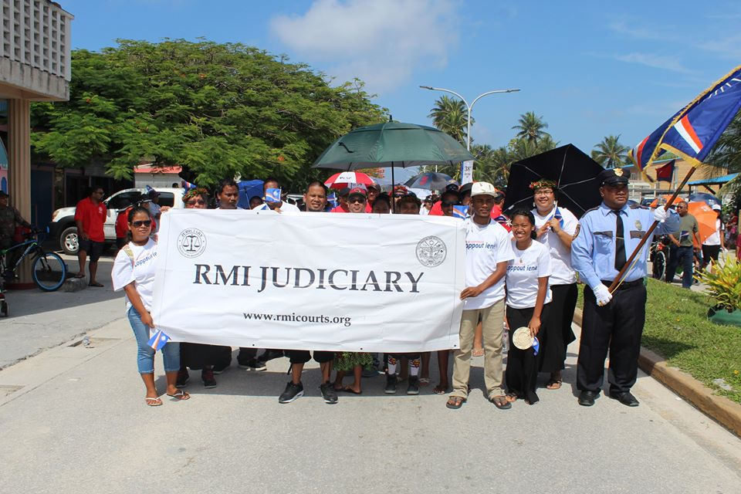

In addition to their administrative responsibilities, the clerks also serve as interpreters from Marshallese to English and English to Marshallese. In 2017, the Office of the Attorney-General had a Chinese translator on staff provided by the Republic of China (Taipei) Embassy. The clerks also assist unrepresented court-users complete forms.

The Office of the Clerk of the Courts is open 8:30 a.m. to noon and 1:00 p.m. to 4:30 p.m., Monday through Friday, except holidays. In case of emergencies, the courts will open on weekends and holidays. The contact information for the Majuro and the Ebeye Courthouses is as follows:

Majuro Courthouse

P.O. Box B

Majuro, MH 96960

Tel.: (011-692) 625-3201/3297

Email: [Marshall.Islands.Judiciary@gmail.com](mailto:Marshall.Islands.Judiciary@gmail.com)

The Majuro Courthouse is located in Uliga Village, Majuro Atoll, across from the Uliga Dock.

Ebeye Courthouse

P.O. Box 5944

Ebeye, Kwajalein Atoll, MH 96970

Tel.: (011-692) 329-4032

Email: [ebeyecourthouse@gmail.com](mailto:ebeyecourthouse@gmail.com)

The Ebeye Courthouse is located behind the Police Station on the Oceanside.

## I. Professional Development and Regional Conferences

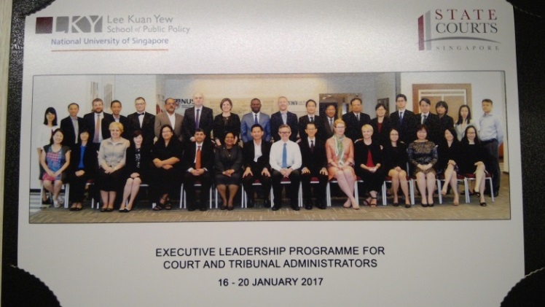Managing the RMI Judiciary’s personnel in accordance with sound leadership and management practices is the fourth goal of the RMI Judiciary’s 2014-2018 Strategic Plan. Consistent with this goal, Strategies 4.1, 4.2, and 4.3, and internationally recognized practice, the RMI Judiciary in 2017 organized and facilitated professional development opportunities for both judges and court staff. All permanent justices and judges of the Supreme Court, the High Court, the Traditional Rights Court, and the District Court attended such workshops and conferences. Seventeen of 20 Community Court judges attended two workshops in Majuro and some observed the District Court while they were in Majuro for other reasons. All seven clerks attended professional development workshops. The participants found that the programs met or exceeded their expectations, and addressed recognized training needs. Funding for such programs came from the RMI Judiciary’s annual operating budget, the Compact of Free Association, New Zealand, and Australia. The RMI Judiciary’s 2017 professional development activities are set forth below.

Chief Clerk of the Courts, Ingrid K. Kabua, attended the Singapore State Courts “Executive Leadership Program for Court and Tribunal Administrators” on January 16-20, 2017, in Singapore. To have a modern court or tribunal system that is efficient and effective, court and tribunal administrators holding senior or management positions must exercise a broad range of professional management skills to manage resources, people, facilities, other assets, information technology, and the day-to-day operations. They are also required to provide strategic guidance to assist the Courts and Tribunals to take advantage of the opportunities provided by the emerging new technologies and information and the challenges posed by the rising demands and changing societal and economic trends. The Executive Leadership Program for Courts and Tribunal Administrators was a five-day intensive and interactive training program designed and contextualized for court and tribunal administrators holding leadership positions, to equip them with key interdisciplinary leadership skills to run courts and tribunals effectively and efficiently. The program also helped the participants gain a broader perspective of the complex issues and policies governing court administration. To ensure an optimal learning experience, evidence-based case studies and a learning journey were used to facilitate interactive discussions among the participants.

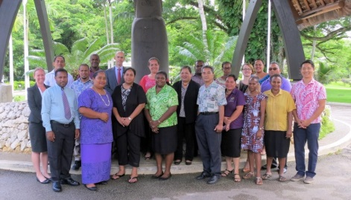Deputy Chief Clerk Travis Joe attended the Pacific Judicial Strengthening Initiative (PJSI) Project Management and Evaluation Workshop on February 20-24, 2017, in Port Vila, Vanuatu. One participant from each PJSI partner was invited to attend this workshop in Port Vila. Each participant was selected by their court on the basis of having responsibility to develop and manage ongoing judicial/court development activities. The workshop enabled participants to reflect and build on prior experiences implementing or managing projects, impart new knowledge and skills to manage projects effectively, apply project management tools to participants’ projects, and share approaches that maximize positive and sustainable project results.

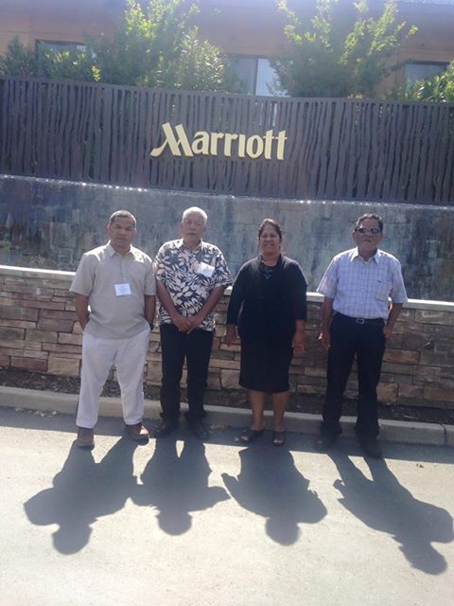As part of the Chief Secretary Office’s efforts to strengthen capacity and provide leadership trainings for all senior level public servants, it organized, through the assistance and support of the USDA Graduate School, a Leadership Workshop in Majuro from March 29-30, 2017. The workshop was conducted by Mr. Glenn Furuya, Founder, President, and CEO of Leadership Works, LLC. The workshop was structured around the following essential keys to leadership success: change management, leadership, purpose, principles, process, and people. The workshop was attended by Chief Clerk of the Courts Ingrid K. Kabua and Deputy Chief Clerk Travis Joe.

The three Traditional Rights Court judges, Chief Judge Walter K. Elbon and Associate Judges Nixon David and Grace Leban, along with District Court Associate Judge Davidson T. Jajo, attended the National Judicial College Court course “Enhancing Judicial Bench Skills” on April 24-27, 2017, in Napa Valley, CA. The efficient administration of modern justice systems requires a team of competent court personnel with knowledge and skills to conduct a complex array of operational activities. The course enhances the ability of judges and court administrators to evaluate the performance of their courts in key performance areas (such as budgeting, calendaring, case management, and personnel administration) and develop practical approaches for making improvements. Judges and court administrators or court clerks who are responsible for court operations and management were encouraged to attend the course.

High Court Associate Justice Colin R. Winchester attended the National Judicial College course “General Jurisdiction” on April 24 to May 4, 2017 in Reno, NV. Designed for the newer judge, the course introduces judges to a variety of subjects and skills they will need and use in their judicial career. Both academic and experiential teaching techniques are used to provide judges with the solid, basic understanding of various topics, from ruling on evidence to handling the self-represented litigant. In addition to the substantive law sessions, the judges learn about courtroom control, ethical pitfalls and solutions, effective communication techniques, and decision-making strategies. After the judges’ nine days at The National Judicial College, they have the tools and resources to face most courtroom situations with confidence.

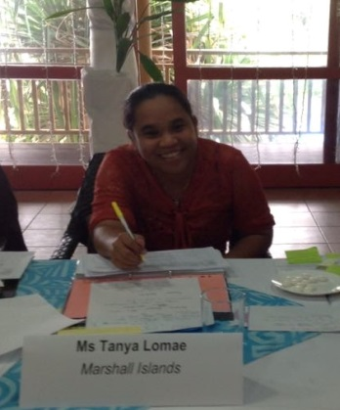Supreme Court Chief Justice Daniel Cadra and High Court Chief Justice Carl B. Ingram attended the 2017 Ninth Circuit Judicial Mid-Winter Workshop from January 29 to February 1, 2017, in Tucson, AZ. The sessions presented included the following: opening; prison condition litigation; Fourth Amendment and surveillance issues; jurisdiction in Indian Country; ethics, the appearance of impropriety and recusal issues; steps to ensure IT security; environmental science in court; current First Amendment issues; directing cases involving electronically stored information; to seal or not to seal the United States’ borders; roles, regulation, and ethics of drones; drone demonstration; perceptions of justice through the media; Supreme Court review; Ninth Circuit review; and closing.

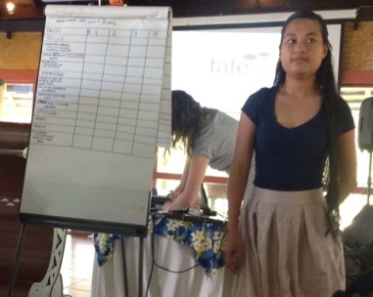 Assistant Clerks of the Courts Tanya Lomae, Ronna Helkena, and Item Note attended the PJSI sponsored Regional Certificate Level Training of Trainers Workshop from June 12-23, 2017 in Rarotonga, Cook Islands. The aim of the workshop is to provide participants with a trainer-the-trainer program that will equip them to be confident and competent trainers and enable them to build capacity within their own courts and/or the region. The two-week workshop covered topics including the following: conducting a TNA (training needs analysis), teaching methods, identifying the proper teaching aids, how to assess learning, developing session plans for training sessions. At the end of each week, the participants were required to do design a short training program and present it to their groups. Chief Clerk Ingrid Kabua, who is a member of PJSI’s Regional Training Team, was invited to the workshop to assist the workshop facilitators during the two weeks.

Chief Clerk of the Courts Ingrid K. Kabua attended the National Association Court Management (NACM) - International Association for Court Administrators (IACA) Joint Educational Conference from July 9-13, 2017, in Washington, D.C., USA. The NACM and the IACA recognize the important role that the court administration profession plays worldwide and partnered to provide an outstanding educational conference. The conference theme, Excellence on a Global Scale, reflects the commitment of both NACM and IACA to the worldwide improvement of the administration of justice. Today’s court leaders, administrators and judges are faced with a myriad of challenges that must be addressed 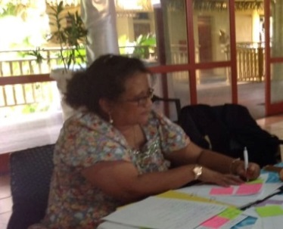effectively to fulfill the public’s trust in them as public servants. The conference agenda included six plenary and over 48 breakout sessions. Topic areas included: Equal Access to Justice; Court Governance and Leadership; Technology and Its Deployment; Promoting the Rule of Law; NACM Core (with the copyright); Independence and Accountability of the RMI Judiciary; Space, Facilities, Security; and many other sessions to strengthen court professionals.

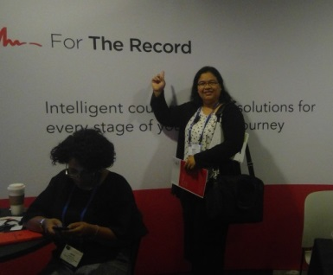Supreme Court Chief Justice Daniel Cadra attended the 2017 Ninth Circuit Judicial Conference from July 16 to 21, 2017, in San Francisco, California. The sessions presented included the following: welcoming; staggering incarceration and recidivism rates; Executive Order 9066 to incarcerate people of Japanese descent; tour of de Young Museum; the state of civics education; Supreme Court review; public confidence in the election process; Pacific Islands Committee meeting; the future of AI; cyber security risks; Academy of Sciences Museum; the future of science in the court room; Fake News; mediation training; and closing.

From August 10 to 11, 2017, the RMI Judiciary’s training team participated in a Train-the-Trainer (TOT) Refresher and Planning Workshop. The objectives of this workshop were to: 1) Refresh the RMI Faculty with the PJSI toolkits (the Trainer’s Toolkit & Judges’ Orientation Toolkit); 2) Refresh faculty on applying effective techniques of adult learning; and 3) Finalize preparation and coordination of the Judicial Orientation Course for Community Court Judges held from August 14-18, 2017. 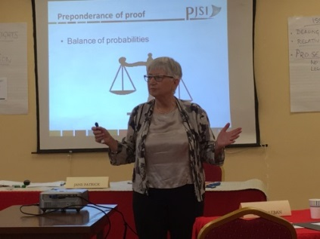The TOT Workshop was conducted by Director of PJSI, Dr. Livingston Armytage, together with Judge Jane Patrick from the County Court of Victoria. Participants in the TOT included the following: Presiding Judge Milton Zackios and Associate Judge Ablos Paul of the District Court, Chief Judge Walter Elbon and Associate Judge Grace Leban of the TRC, Chief Clerk Ingrid Kabua, Deputy Chief Clerk Travis Joe, and Assistant Clerks Tanya Lomae and Item Note from the Office of the Clerk of Courts, all of whom have attended PJSI TOT workshops and are members of the RMI Judiciary’s training team.

From August 14-18, 2017, a five-day orientation workshop was conducted for lay judges of the Community Courts from across the Republic. This was for the judges their first structured induction on the basic principles and practices of the judicial role. Topics covered included court administration, civil law, criminal law, evidence, constitutional protections, domestic violence, decision making, judicial ethics and the RMI Code of Judicial Conduct. The orientation was presented by a faculty of 9 judicial and clerical officers for the RMI courts, together with Judge 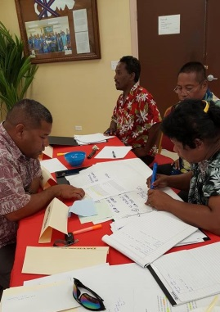Jane Patrick from the County Court of Victoria and PJSI’s Dr. Armytage. This faculty successfully applied a range of presentation skills developed and refreshed in the preceding TOT. There was a total of 17 orientation participants, two of whom were females (12%), together with the faculty members who also sat in this course, all a total of 26 participants, of whom seven were female (27%). At the conclusion of the orientation, participants assessed their satisfaction with the training at 94.4% and the usefulness of the information supplied at 98.25%. These scores highlight the participants’ appreciation of this orientation training – the first most had ever received.

Following the Orientation course, a two-day Magistrates Consultation on the RMI’s Domestic Violence Prevention and Protection Act 2011 (DVPPA) was conducted for the Community Court judges from August 21-22, 2017. The course was organized by the Pacific Community (SPC), with Australian Aid. The course objectives were to discuss the link between gender, human rights, and domestic violence; to discuss some of the specific legal issues faced when applying the DVPPA, including key successes and challenges; and to develop tools to support the courts in its work on domestic violence. Tools were developed and translated into Marshallese, include two hearing guidelines – for handling criminal cases under the DVPPA and for issuing protection orders under the Act.

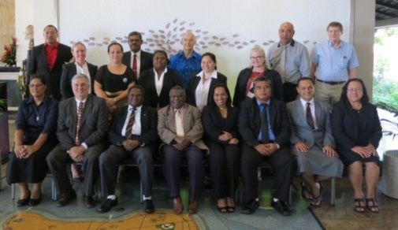High Court Chief Justice Carl Ingram attended the 17th Conference of Chief Justices of Asia and the Pacific in Tokyo, Japan, from September 18-21, 2017 (“CJ’s Conference”). Participants at the CJ’s Conference heard presentations and participated in discussions under the following topics: current challenges for capacity building; building public confidence in the administration of justice; interaction with the media and use of social media; public information and access to justice programs; specialized courts; limiting appeals; recourse identification; professional development programs; family law and domestic violence; information technology; relations with the executive and legislative branches; and judges as mentors. These topics are consistent with all seven goals of our Strategic Plan: Strategic Goal 1, To be Fair, Efficient, and Effective; Strategic Goal 2, To be Affordable and Accessible; Strategic Call 3, To be Independent, yet Transparent and Accountable; Strategic Goal 4, To Manage the RMI Judiciary's Personnel in Accordance with Sound Leadership and Management Practices; Strategic Goal 5, To Manage the RMI Judiciary’s Buildings and Equipment in Accordance with Sound Management Practices; Strategic Goal 6, To Manage the RMI Judiciary’s Financial Resources in Accordance with Sound Financial Practices; and Strategic Goal 7, To Identify, Develop, and Employ Innovative Approaches to Achieving the RMI Judiciary’s Strategic Goals.

High Court Associate Justice Colin Winchester attended the PJSI’s Regional Judicial Leadership Workshop in Nuku’alofa Tonga from September 5 through September 7, 2017. The intensive three-day workshop covered leadership skills and traits, judicial leadership issues in Pacific nations, case studies in international judicial leadership, common issues facing Pacific judiciaries, and the successful implementation of change. The workshop required each participant to select an area of needed improvement in his/her judiciary, propose a needed change, develop a change plan, and present the change plan to the facilitators and other workshop participants. For his change plan, Associate Justice Winchester selected the improvement of the RMI’s domestic violence laws and procedures, with the goal of having the Nitijela adopt improved domestic violence laws and procedures within the next two years.

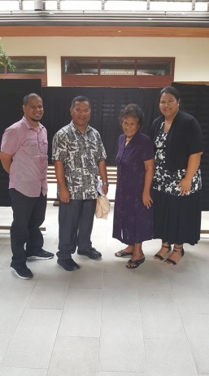Associate Justice Winchester also attended the 2017 Court Technology Conference in Salt Lake City, Utah from September 12 through September 14, 2017. The conference consisted of plenary sessions and breakout sessions addressing such topics as prevention of security breaches, prevention of identity theft, implementation of e-filing software, implementation and improvement of case management systems, remote access to judicial proceedings via digital technologies, and current and future IT trends in federal, state and local judiciaries. The primary purpose of Associate Justice Winchester’s attendance was to meet one-on-one with those vendors who had expressed an interest in providing the RMI judiciary with e-filing software and integrated case management software. Associate Justice Winchester was also able to spend several hours with IT administrators at the Utah Administrative Office of the Courts, who have agreed to provide insight and information as the RMI Judiciary explores and implements e-filing and digital case management systems.

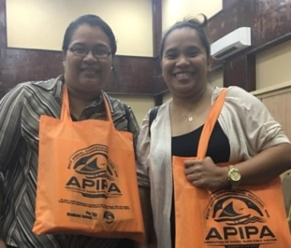 Chief Clerk of the Court Ingrid K. Kabua and Assistant Clerk of the Court Tanya Lomae, who are responsible for the RMI Judiciary’s finances, attended the 2017 Annual Conference of the Association of Pacific Island Public Auditors (“APIPA”), which was held in Majuro, Marshall Islands from August 21-25, 2017. The 2017 APIPA conference offered four tracks: Audit, Audit Supervisor, Finance, and Accounting and Management. The two clerks took the Finance and Accounting and Management tracks which included the following courses: Government Accounting Basics, Implementing Internal Controls and Quality Assurance for Program Managers, Emotional Intelligence and Dealing with Difficult Personalities, Skills for Leading and Managing Staff, & Priority Based Budgeting.

Two Marshall Islands District Court judges, Associate Judge A. Tarry Paul and Associate Judge Davidson T. Jajo, attended the National Judicial College course “Behind the Wheel: Today’s Traffic Offender” from October 23-26, 2017, in Reno, Nevada. Traffic cases are arising in today’s courts at an increasing, regular frequency. The issues involved in these cases are numerous and complex, ranging from stop sign and speeding, to more complex issues such as driving under the influence. Attending this course is beneficial for all traffic judges in order to give them the best chance at keeping up-to-date with current traffic issues, while also learning the skills on how to effectively manage and sentence today’s traffic offenders.

Ebeye District Court Associate Justice Davidson Jajo, TRC Associate Judge *pro tem* Risi Graham, Chief Clerk of the Courts Ingrid K. Kabua, and Deputy Chief Clerk Travis Joe traveled to the Solomon Islands to attend the Regional Lay Judicial Officer Orientation Course sponsored by the Pacific Judicial Strengthening Initiative (“PJSI”) from 20-24 November, 2017. The purpose of the course is to promote the competence of newly-appointed non-law trained (lay) judicial officers being judges and magistrates to perform their duties, and to promote excellence in the delivery of justice across the Pacific region. PJSI further supported having Clerks Kabua and Joe attend the course in an effort to increase the knowledge, skills, and attitudes necessary for senior staff to competently administer judicial functions as *pro tem* judges.

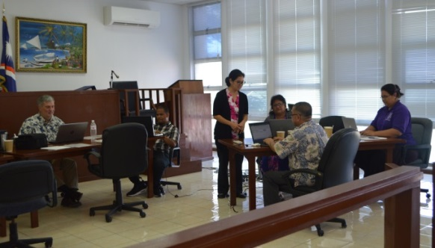California based IT Trainer Lynn Muscat travelled to Majuro to teach Microsoft Office, Word, Excel, and Highlights of Access. The training took place November 27-30 (Monday-Thursday) at the Majuro Courthouse. Microsoft Office is a very useful tool to know and be familiar with. Staff and judges were trained in MS Word paragraph formatting, Excel (sorting, filtering, graph functions), PowerPoint, and developed RMI Judiciary templates for presentations.

## J. Court Rules and Relevant Statutes

To enhance access to justice, the RMI Judiciary regularly reviews and amends or seeks amendments of its rules of procedure, Evidence Act, and other statutes. Over the past 10 years, the RMI Judiciary has adopted or proposed more than 15 sets of amendments.

Effective January 9, 2017, the RMI Judiciary updated the Marshall Islands Code of Judicial Conduct in a number of ways, including the following. For ease of citation, the term “Canon” was changed to “Articles” and the term “Applications” was changed to “Sections.” Language limiting public comments by judges was inserted in Section 2.4.1. For ease of reading, the language following Section 2.5.5 that sets forth exceptions for disqualification was re-structured and clarified. The phrase “shall not use or lend” was changed to “shall not abuse” to clarify and narrow prohibitions regarding use of the prestige of office in Sections 4.8 and 4.10.5. The reporting requirements set forth in Section 4.18.1 were limited to full-time judges and the chief justice of the Supreme Court. Section 7.7 was amended to ensure that the head of a court will inform the complainant, the subject judge, and the Judicial Service Commission of action taken to admonish or reprimand a judge for inappropriate conduct. The language in Section 7.12.1 was rewritten for clarity regarding the grounds for dismissing complaints.

Effective May 18, 2017, the RMI Judiciary updated the Marshall Islands Rules of Civil Procedures in several way. At the suggestion of counsel, Rule 7(b)(1)(D) was amended to require that affidavits be based upon personal knowledge. As requested by counsel, Special Rules regarding maritime claims and forfeitures were added. Changes were made to Rule 75 regarding the disqualification of judges to conform with changes made to the Code of Judicial Conduct.

Effective March 30, 2017, the Motor Traffic (Amendment) Act 2017 was enacted. The purpose of the Act was to amend the Motor Traffic Act 1986, 13 MIRC Chp. 1, to provide that 100% of the fine collected from drivers not using seatbelts is to be paid to the Justice Special Revenue Fund rather than 50% to the Justice Special Revenue fund and 50% to the Judiciary Fund. The RMI Judiciary requested the bill because it did not wish to receive a portion of the fines that it imposes. The RMI Judiciary does not want to have, or appear to have, a conflict.

# IV. THE JUDICIAL SERVICE COMMISSION: JUDICIAL APPOINTMENTS

Along with the courts, the Constitution provides for a Judicial Service Commission, which consists of the Chief Justice of the High Court, as chair, the Attorney-General, and a private citizen selected by the Cabinet. The private member is Maria K. Fowler. The JSC nominates to the Cabinet candidates for appointment to the Supreme Court, High Court and TRC, and the Commission appoints judges to the District Court and the Community Courts. In appointing Community Court judges, the Commission takes into consideration the wishes of the local communities as expressed through their local government councils. The Commission also may make recommendations to the Nitijela regarding the qualifications of judges. In the exercise of its functions and powers, the Commission does not receive any direction from the Cabinet or from any other authority or person but acts independently. The Commission may make rules for regulating its procedures and generally for the better performance of its functions. The Commission also reviews complaint against judges.

In 2017, the Commission nominated to the Cabinet for re-appointment, two Supreme Court acting justices. Also, the Commission appointed or renewed the appointments of four Community Court judges.

# V. ACCOUNTABILITY: CODES OF CONDUCT AND COMPLAINTS

The third goal of the RMI Judiciary’s Strategic Plan includes *“to be accountable.”* To enhance its transparency and accountability, the RMI Judiciary has adopted internationally recognized standards for judicial conduct and attorney conduct. These standards are available to the public as are the procedures for lodging complaints against judges, attorneys, and court staff.

With respect to judicial conduct, the RMI Judiciary has adopted the Marshall Islands Code of Judicial Conduct 2008 (revised January 9, 2017). The Code is based principally upon the Bangalore Principles and the American Bar Association model Code of Judicial Conduct. A copy of the RMI Judiciary’s code can be found on its website, [www.rmicourts.org/](http://www.rmicourts.org/.) under the heading “The Marshall Islands and Its Judiciary.” The provisions for lodging and processing complaints against judges start on page 12 of the code.

In 2017, no complaints were lodged against the judges. In the past five years, only one complaint has been lodged against a judge. In late 2015, a litigant complained that a judge did not listen to her. In January 2017, the Judicial Service Commission resolved the matter finding no wrongdoing by the judge and referred the matter to the High Court Chief Justice to counsel the subject judge. This is the only complaint made in the past five years for all courts and all judges.

With respect to attorney conduct, the RMI Judiciary has adopted the American Bar Association’s Rules of Professional Conduct. Provisions for lodging and processing complaints against attorneys can be found on the RMI Judiciary’s website under the heading “Rules of Admission and Practice.” The Supreme Court and High Court have appointed an attorney-committee to hear complaints. In 2017, no complaints were lodged against attorneys. At the beginning of 2017, there were four complaints from 2013 pending review by the attorney-committee and one complaint from 2015. Of the five pending complaints, four were resolved in January 2017 and the remaining one was resolved in May 2017.

With respect to court staff, the RMI Judiciary maintains a complaint box at the courthouses. In 2017, no complaints were lodged against court staff. Nor have there been any complaints lodged against court staff within the past five years.

# VI. FACILITIES, TECHNOLOGY, AND LIBRARY

Administering the RMI Judiciary’s buildings and equipment in accordance with sound management practices is the fifth goal of the RMI Judiciary’s Strategic Plan.

## A. Facilities

Over the recent past, the RMI Judiciary, with funding from court fees and from the Cabinet, the Nitijela, and the Republic of China (Taiwan), has renovated the Majuro Courthouse and the Ebeye Courthouse to make them safe, secure, and accessible. The projects have included renovating the Ebeye Courthouse, adding a ground-floor courtroom at the Majuro Courthouse, renovating of the chambers of the Traditional Rights Court in Majuro, repainting the Majuro Courthouse and replacing the roof, and installing a 100KVA backup generator for the Majuro Courthouse.

In 2017, the RMI Judiciary built a police substation next to the Majuro Courthouse. In early 2018, the utilities were installed, and the National Police Department started manning the sub-station in March 2018.

Also, in 2017, the RMI Judiciary sought funding for a new courthouse on Ebeye. The Ebeye Courthouse building has deteriorated to the point where its needs to be replaced. It is in bad condition and cannot be expanded to meet the RMI Judiciary’s and Kwajalein community’s needs. Unfortunately, the RMI Judiciary did not receive the funds it requested. The RMI Judiciary will renew its request for this vital project.

## B. Technology

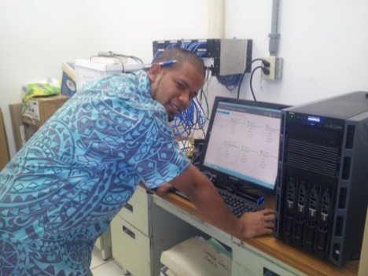The courthouses on Majuro and Ebeye are equipped with computers, printers, and photocopiers and have Internet access (@ 7.0 Mbps in Majuro and 1.5 Mbps in Ebeye). The courts permit the filing and service of documents via email attachment. The computers in Majuro are linked together in a network, and the Majuro Courthouse has three scanners with OSC software permitting the courts to scan documents and send them almost anywhere in the world. Over the past four years, the RMI Judiciary has replaced all but two of its older computers. Those computers will be replaced in 2018. Software updates remain a critical need and from time-to-time computers crash and must be replaced.

Currently, the High Court permits off-island counsel to attend status and scheduling conferences via telephone and Skype. Occasionally, evidence in uncontested matters is taken via Skype or telephone. However, more band width is needed to provide stable video conferencing for contested matters.

## C. Library

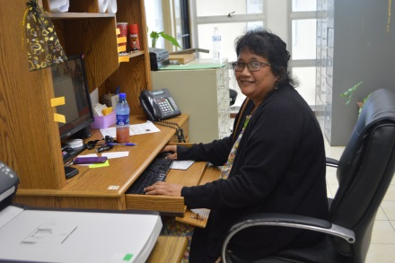The RMI Judiciary has a small, but functional, law library which includes hard copies of the following: United States Supreme Court cases through 2015; American Law Reports First, Second, Third, Fourth, part of Fifth, and Federal; LaFave on Criminal Law, Criminal Procedure, and Search and Seizure; Wharton on Criminal Law and Criminal Procedure; American Jurisprudence 2nd; Wright and Miller on Federal Practice and Procedure; Moore’s Federal Practice; some Restatements of the Law; and others. Also, the RMI Judiciary has up to date online access to United States case law and secondary sources through a WestLaw Internet subscription.

# VII. ANNUAL BUDGET AND AUDIT REPORT

Managing the RMI Judiciary’s financial resources in accordance with sound financial practices is the sixth goal of the RMI Judiciary’s Strategic Plan. This is evidenced not only by the work of the courts, but also by the RMI Judiciary’s management of the funds made available to it.

For FY 2017, the Nitijela appropriated $1,082,859 for the RMI Judiciary: $762,381 for salaries and wages and $320,478 for all others. Less audit expenses of $8,595 paid out by the Ministry of Finance, a total of $311,883 was paid to the RMI Judiciary for its operational funds.

Of the $762,381 appropriated for personnel in FY 2017, the RMI Judiciary only expended $638,397.65 because of vacancies and unexpended salaries in the High Court and the Community Courts. The unspent personnel funds from FY 2017, $123,983.35, remained in the General Fund with the Ministry of Finance.

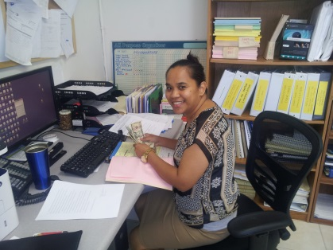

Of the $320,478 appropriated in FY 2017 for all other expenses, $8,595 was retained by the Ministry of Finance for audit expenses and the RMI Judiciary expended or obligated the remaining $311,883.

From operations funds, the RMI Judiciary has segregated moneys the Nitijela appropriated for the Legal Aid Fund. As of September 30, 2017, the RMI Judiciary had $216,447.02 in its Legal Aid Fund account, much of which had been obligated for payment to attorneys to represent those who cannot offer an attorney and cannot be represented by the Micronesian Legal Aid Services Corporation and the Office of the Public Defender.

Apart from Nitijela appropriations, the RMI Judiciary by Act has its own special revenue fund (“RMI Judiciary Fund”). Court fines and fees (excluding national criminal fines and local government fines) collected by the Office of the Clerk of the Courts are deposited into this fund, as are funds from other sources. Collections by the Office of the Clerk of the Courts and deposited into the RMI Judiciary Fund in FY 2017 totaled $63,025.31. As highlighted in the Significant Events or Accomplishments section of this report (page 6), funding for the construction of a police sub-station at the Majuro Courthouse was made possible through the RMI Judiciary Fund. The fund balance at the end of FY 2017, $216,174.57 and monies collected in FY 2017 will be reserved for a new Ebeye courthouse. The Ebeye Courthouse project is in the planning stage and most certainly will need much more additional funding.

For the Marshall Islands Judiciary Fund, Deloitte for FY 2017 reported a clean audit with no unresolved findings. Attached as Appendix 3 is the statement of revenues, expenditures, and changes in the RMI Judiciary Fund balance for years ended September 30, 2016 and 2017 and the Balance Sheets for years ending September 30, 2016 and 2017.

# Appendix 1

**ORGANIZATIONAL CHART**

**FOR THE**

**MARSHALL ISLANDS JUDICIARY**



# Appendix 2

**JUDICIARY PERSONNEL**

**Justices and Judges**

Supreme Court Chief Justice Daniel N. Cadra (9/21/13-9/20/23)

High Court Chief Justice Carl B. Ingram (10/5/13-10/4/23)

High Court Associate Justice Colin R. Winchester (11/3/16-11/2/18)

Traditional Rights Court Chief Judge Walter K. Elbon (7/04/10-7/03/20)

Traditional Rights Court Associate Justice Nixon David (4/7/13-4/6/17)

Traditional Rights Court Associate Justice Grace L. Leban (7/04/10-7/03/20)

Presiding District Court Judge Milton Zackios (4/5/15-12/25/18)

Associate District Court Judge A. Tarry Paul (11/30/15-11/29/25)

Associate District Court Judge Davidson T. Jajo (Ebeye) (4/18/16-4/17/26)

Ailinglaplap Community Court Presiding Judge Canover Katol (5/4/14-5/3/18)

Ailinglaplap Community Court Associate Judge Clandon Katjang (5/4/14-5/3/18)

Ailinglaplap Community Court Associate Judge Mannu Rakin (7/13/14-7/12/18)

Ailuk Community Court Presiding Judge Tilly Menua (2/9/14-2/8/18)

Arno Community Court Presiding Judge (vacant)

Arno Community Court Associate Judge (vacant)

Arno Community Court Associate Judge Batle Latdrik (2/9/14-2/8/18)

Aur Community Court Presiding Judge Benty Jikrok (03/03/17-03/02/23)

Bikini and Kili Community Court Presiding Judge Kener Lewis (4/18/16-4/17/22)

Ebon Community Court Presiding Judge Jurelon Alik (09/17/17-09/16/23)

Enewetak and Ujelang Community Court Presiding Judge (vacant)

Jabat Community Court Presiding Judge Tari Jamodre ((8/7/16-8/6/22)

Jaluit Community Court Presiding Judge Hertina Mejjena (7/13/14-7/12/18)

Jaluit Community Court Associate Judge Junior Helmi Morris (01/22/17-01/21/23)

Lae Community Court Presiding Judge (vacant)

Lib Community Court Presiding Judge (vacant)

Likiep Community Court Presiding Judge Riton Erakdrik (07/25/16-07/24/22)

Maloelap Community Court Presiding Judge (vacant)

Maloelap Community Court Associate Judge (vacant)

Mejit Community Court Presiding Judge Rebecca John (1/25/15-1/24/21)

Mili Community Court Presiding Judge Jiton John (01/22/17-01/21/23)

Namdrik Community Court Presiding Judge Reio Lolin (7/13/14-7/12/18)

Namu Community Court Presiding Judge (vacant)

Rongelap Community Court Presiding Judge (vacant)

Ujae Community Court Presiding Judge Area Jibbwa (7/13/14-7/12/18)

Utrik Community Court Presiding Judge Jackel Moore (09/17/17-09/16/23)

Wotho Community Court Presiding Judge Carlmai Antibas (9/23/16-9/22/22)

Wotje Community Court Presiding Judge Lincoln Lakjohn (3/18/16-3/17/22)

Wotje Community Court Associate Judge Mejwadrik Elbon (8/9/15-8/8/21)

Unallocated (vacant)

**Judicial Service Commission**

High Court Chief Justice Carl B. Ingram, Chair

Attorney-General Filimon M. Manoni, Member

Maria K. Fowler, Member Representing the Public

**Staff**

Chief Clerk of the Courts Ingrid K. Kabua

Deputy Chief Clerk of the Courts Travis Joe

Assistant Clerk of the Courts Armen Bolkeim (Ebeye)

Assistant Clerk of the Courts Hainrick Moore

Assistant Clerk of the Courts Tanya Lomae

Assistant Clerk of the Courts Ronna Helkena

Assistant Clerk of the Courts Item Note

Bailiff Junior Borran, Lieutenant

Bailiff Jukku Benjamin, Sergeant

Bailiff Moses Lautej, Police Officer I

Maintenance James Milne

# Appendix 3

|  |  |  |  |
| --- | --- | --- | --- |
|  | 2017 |  | 2016 |
| Revenues: |  |  |  |
| Nitijela appropriation | $ 950,281 |  | $ 916,908 |
| Court fines and fees | 95,884 |  | 67,897 |
| Interest | 1,829 |  | 934 |
| Other | 40,007 |  | 34,132 |
| Total Revenues | 1,088,001 |  | 1,019,871 |
|  |  |  |  |
| Expenditures: |  |  |  |
| Salaries, wages, and benefits | 638,398 |  | 573,620 |
| Leased housing | 71,250 |  | 56,250 |
| Travel | 53,578 |  | 64,451 |
| Supplies and materials | 44,559 |  | 119,585 |
| Utilities | 39,033 |  | 39,870 |
| Communications | 37,873 |  | 48,443 |
| Professional services | 28,515 |  | 23,391 |
| POL | 11,110 |  | 7,967 |
| Repairs and maintenance | 8,190 |  | 8,938 |
| Capital outlay | 8,069 |  | 44,801 |
| Miscellaneous | 33,265 |  | 30,634 |
| Total expenditures | 973,840 |  | 1,018,490 |
| Net change in fund balance | 114,161 |  | 1,381 |
| Fund balance at the beginning of the year | 316,960 |  | 315,579 |
| Fund balance at the end of the year | $ 431,121 |  | $ 316,960 |
|  |  |  |  |
| See accompanying notes to financial statements. |  |  |  |

**MARSHALL ISLANDS JUDICIARY FUND**

Statements of Revenues, Expenditures, and Changes in Fund Balance

Years Ended September 30, 2017 and 2016

|  |  |  |  |
| --- | --- | --- | --- |
| **MARSHALL ISLANDS JUDICIARY FUND** | | | |
|  |  |  |  |
| Balance Sheets | | | |
| September 30, 2017 and 2016 | | | |
|  |  |  |  |
|  | 2017 |  | 2016 |
| ASSETS |  |  |  |
| Cash | $ 432,457 |  | $ 314,664 |
| Accounts receivable | $ 4,269 |  | $ 9,099 |
|  | $ 436,726 |  | $ 323,763 |
| LIABILITIES AND FUND BALANCE |  |  |  |
| Liabilities: |  |  |  |
| Other liabilities and accruals | $ 5,605 |  | $ 6,803 |
|  |  |  |  |
| Contingency |  |  |  |
|  |  |  |  |
| Fund balance: |  |  |  |
| Committed | $ 431,121 |  | $ 316,960 |
| Total liabilities and fund balance | $ 436,726 |  | $ 323,763 |
|  |  |  |  |
|  |  |  |  |
| See accompanying notes to financial statements. |  |  |  |

1. Other charges: Fishing w/o consent; Unauthorized sale to minors, Unauthorized Hours of Operation/Package Store, & Underage at bar/premises.